**MULTISENSORY FUSION FOR UNDERWATER ROBOT LOCALIZATION AND EXPLORATION**

**BY**

**UMAIR ALI**

**18001222019**

**MS Electrical Engineering**

**Department of Electrical Engineering**



**UNIVERSITY OF GUJRAT**

**Session 2018-2020**

**UMAIR ALI M.Sc Electrical Engineering 2018-20**

**MULTISENSORY FUSION FOR UNDERWATER ROBOT LOCALIZATION AND EXPLORATION**

**A Thesis Submitted in Partial Fulfillment of the Requirements for the Award of Degree of**

**MS**

**In**

**Electrical Engineering**

**BY**

**UMAIR ALI**

**18001222019**

**Department of Electrical Engineering**



**UNIVERSITY OF GUJRAT**

**Session 2018-20**

**ACKNOWLEDGEMENT**

I would like to thank Allah Almighty who blessed me with a very motivating and kind supervisor, Dr. Muhammad Wasif who has been always available to help me wherever I faced any difficulty. He always provided me a challenging environment so I could build up an ability to learn something new. I cannot forget his patience, availability, and supportive nature so I could complete my thesis in time.

**(Umair Ali)**

**DEDICATION**

Dedicated to my parents who supported me to fulfill my dreams.

**(Umair Ali)**

**DECLARATION**

I Umair Ali S/O Muhammad Sajjad Haider, roll # 18016522-008, MS Electrical Engineering scholar, Department of Electrical Engineering, Faculty of Engineering & Technology, University of Gujrat, Pakistan, hereby solemnly declare that this thesis titled “Multisensory Fusion for Underwater Robot Localization and Exploration” is based on genuine work, and has not yet been submitted or published elsewhere. I Furthermore, I shall not use this thesis for obtaining any other degree from this university or any other institution.

I also understand that if evidence of plagiarism is provided in my thesis at any stage, even after the award of the degree, the degree may be cancelled and revoked by the University authority.

**(Umair Ali)**

It is certified that Umair Ali S/O Muhammad Sajjad Haider, roll # 18016522-008, M.Sc Electrical Engineering scholar, Department of Electrical Engineering, Faculty of Engineering & Technology, University of Gujrat, Pakistan, worked under my supervision and the above stated declaration is true to the best of my knowledge.

**_____________________**

Dr. Syed Muhammad Wasif

Assistant Professor, Department of Electrical Engineering

University of Gujrat, Punjab, Pakistan.

Email: syed.wasif@uog.edu.pk

Dated:

**THESIS** **COMPLETION CERTIFICATE**

It is certified that this thesis titled “Multisensory Fusion for Underwater Robot Localization and Exploration” submitted by Umair Ali S/O Muhammad Sajjad Haider, roll # 18016522-008, MS Electrical Engineering scholar, Department of Electrical Engineering, Faculty of Engineering & Technology, University of Gujrat, Pakistan, is evaluated and acceptance for the award of the degree ”Master of Science (MS)” in Electrical Engineering by following members of the Thesis/ Dissection Viva Voce Examination Committee.

The evaluation report is available in the Directorate of Advance Studies and Research Board of University.

**_________________________**

Name of External:

Designation:

Office Address:

Email:

**_________________________**

Dr.Syed Muhammad Wasif

Assistant Professor, Department of Electrical Engineering

University of Gujrat, Punjab, Pakistan.

Email: syed.wasif@uog.edu.pk

**_________________________**

Dr.Shahid Iqbal

HOD, Department of Electrical Engineering

University of Gujrat, Punjab, Pakistan.

Email: si@uog.edu.pk

|  |  |
| --- | --- |
| **TABLE OF CONTENTS** | |
| **CONTENTS** | **PAGE** |
| LIST OF FIGURES…………………………………………………………….. | **vi** |
| LIST OF TABLES………………………………………………………… | **vii** |
| LIST OF APPENDICES………………………………………………….. | **viii** |
| ABSTRACT……………………………………………………………….. | **01** |
| CHAPTER 01: INTRODUCTION……………………………………….. | **02** |
| 1.1: Problem Statement……………………………………………… | **05** |
| 1.2: Objectives and Scope of Study...………………..……………. | **05** |
| CHAPTER 02: LITERATURE REVIEW……………………………….. | **06** |
| 2.1: Navigation Systems for Underwater Localization….…………. | **06** |
| 2.1.1: Inertial or Motion Sensors…………………...…………. | **06** |
| 2.1.2: Acoustic Positioning Systems………………….……….. | **08** |
| 2.1.3: SONAR and Vision-based Localization Systems…….. | **10** |
| 2.2: Fusion Algorithms for Underwater Localization……………… | **11** |
| 2.2.1: Kalman Filter…………………………………………….. | **11** |
| 2.2.2: Extended Kalman Filter………………………………….. | **12** |
| 2.2.3: Unscented Kalman Filter………………………………… | **13** |
| 2.2.4: Particle Filter…………………………………………….. | **14** |
| 2.2.5: Machine Learning Methods……………………………… | **16** |
| 2.2.6: Bio-inspired Approaches………………………………… | **17** |
| CHAPTER 03: RESEARCH METHODOLOGY……………………….. | **18** |
| 3.1: PC/BC-DIM Neural Network…………………………………... | **18** |
| 3.1.1: Training of Weights……………………………………………. | **21** |
| 3.1.2: Multisensory Data Fusion……………………………………… | **21** |
| 3.2: PC/BC-DIM Neural Network for UW Localization…………... | **23** |
| 3.2.1: Sensors for Simulations………………………………………... | **23** |
| 3.2.2: Encoding of Sensors………………………………….………… | **24** |
| 3.2.3: Decoding of Reconstructed Input…………………………….. | **24** |
| 3.3: Algorithm of PC/BC-DIM for Underwater Localization …………… | **25** |
| CHAPTER 04: RESULTS AND DISCUSSIONS………………………. | **27** |
| 4.1: Demonstration of PC/BC-DIM Result………………………………… | **27** |
| 4.1.1: Random Noise Addition………………………………………. | **27** |
| 4.1.2: Non-Gaussian or Abrupt Noise Addition……………………… | **29** |
| 4.2: Simulation Data Comparison with a B-PR-F Neural Network………. | **29** |
| 4.2.1: PC/BC-DIM and B-PR-F Comparison………………………… | **30** |
| 4.2.2: All Sensors B-PR-F and without IMU PC/BC-DIM Comparison………………………………………………….…. | **33** |
| 4.2.3: All Sensors B-PR-F and without DVL PC/BC-DIM Comparison…………………………………………………….. | **34** |
| 4.3: Experimental Data Comparison with a B-PR-F Neural Network……... | **34** |
| CHAPTER 05: CONCLUSION AND DISCUSSIONS…………………. | **38** |
|  |  |

|  |  |  |  |
| --- | --- | --- | --- |
| **LIST OF FIGURES** | | | |
| **CONTENTS** | | **PAGE** | |
| Figure-1.1: Connectivity of different sensors for underwater localization………………………………………………….. | | **02** | |
| Figure-1.2: General idea of multisensory fusion ………………………. | | **04** | |
| Figure-2.1: Working principle and geometry of DVL system…………. | | **07** | |
| Figure-2.2: Types and geometry of acoustic positioning system……… | | **08** | |
| Figure-2.3: Visual localization approaches…………………………….. | | **10** | |
| Figure-2.4: Working principle of kalman filter………………………… | | **11** | |
| Figure-2.5: Typical extended kalman filter scheme……………………. | | **12** | |
| Figure-2.6: Comparison of unscented transform (UT) and EKF………. | | **15** | |
| Figure-3.1: PC/BC-DIM processing stages……………………………… | | **19** | |
| Figure-3.2: PC/BC-DIM noisy input reconstruction…………………… | | **20** | |
| Figure-3.3: PC/BC-DIM working principle…………………………….. | | **21** | |
| Figure-3.4: Trained weights of multiple sensors……………………….. | | **22** | |
| Figure-3.5: Fusion of two types of sensory inputs..……………………. | | **22** | |
| Figure-3.6: Encoding of sensory data…………………………………… | | **24** | |
| Figure-4.1: PC/BC-DIM outcome for noisy positioning points……….. | | **28** | |
| Figure-4.2: PC/BC-DIM outcome for 2 times noisy positioning points…………………………………………………………. | | **28** | |
| Figure-4.3: PC/BC-DIM outcome for non-gaussian or abrupt noise….. | | **29** | |
| Figure-4.4: B-PR-F neural network results……………………………… | | **30** | |
| Figure-4.5: PC/BC-DIM neural network results………..………………. | | **31** | |
| Figure-4.6: Error comparison for both neural networks……………….. | | **32** | |
| Figure-4.7: Depth coordinate of B-PR-F neural network……………… | | **32** | |
| Figure-4.8: Depth coordinate of PC/BC-DIM neural network………… | | **33** | |
| Figure-4.9: Noisy USBL vs PC/BC-DIM results for depth coordinate.. | | **33** | |
| Figure-4.10: B-PR-F position estimation……………………………….. | | **36** | |
| Figure-4.11: PC/BC-DIM position estimation…………………………. | | **36** | |
|  | |  | |
|  | |  | |
| **LIST OF TABLES** | | |
| **CONTENTS** | **PAGE** | |
| Table-2.1: Comparison of Conventional State Estimators for UWL…. | **15** | |
| Table-4.1: PC/BC-DIM and B-PR-F Simulation Comparison……………….. | **31** | |
| Table-4.2: PC/BC-DIM and B-PR-F Simulations without IMU…….... | **34** | |
| Table-4.3: PC/BC-DIM and B-PR-F Simulations without DVL……… | **34** | |
| Table-4.4: PC/BC-DIM and B-PR-F Experiment………………………. | **35** | |
|  |  | |

|  |  |
| --- | --- |
| **LIST OF APPENDICES** | |
| **CONTENTS** | **PAGE** |
| APPENDIX-01: Abbreviation Used in the Thesis…………………….. | **46** |
| APPENDIX-02: Turnitin Originality Report…………………………… | **47** |
|  |  |

**ABSTRACT**

Water covers more than 70 percent of the earth and most of the underwater area has not yet discovered. For underwater exploration and unusual activity inspection, Unmanned underwater vehicles (UAVs) are used which have lesser cost and no life risks as compared to manned underwater vehicles. The known position is mandatory to make underwater exploration data meaningful but underwater localization is a challenging research topic because of the dynamic and unstructured nature of the seabed environment. Global positioning system (GPS) and other radio positioning systems e.g., cellular networks and Wireless Fidelity (Wi-Fi) positioning systems (WPS) are not suitable for underwater location estimation. Acoustic positioning systems are a better alternative for underwater localization but sound traveling speed is slower than electromagnetic signals. The sensors which can estimate the position in an absolute frame of reference in the underwater environment e.g., visual positioning systems and acoustic positioning systems have a slower position update rate. For the sake of reliability, dead-reckoning method based sensors like Doppler velocity log (DVL) and inertial measurement unit (IMU) are added. By fusing these sensor modalities, the location of the underwater vehicle is located with more accuracy. In the case of fusion of multiple sensors, Kalman filter can not deal with non-Gaussian noise while parametric filter like monte Carlo localization (MCL) has a high computational cost. The particle filter is great for dealing with highly non-linear systems but because of expensive computation cost, they are suitable for post-processing. An optimal fusion policy for the localization of underwater robots with a low computational cost is an important research question. We proposed PC-BC/DIM neural network which can fuse multiple sensors and optimally approximate position using different sensory information. Simulation results have shown that our proposed filter has only 1.761 standard deviation error, 3.9618 roots mean square error, 0.8 milliseconds of filter processing time with 18.79 seconds of total execution time against 6301 IMU, 6301 DVL and 158 USBL values. Experimental results have 1.3526 roots mean square error and 1.0412 standard deviation error for the complete trajectory of 693 meters. The proposed Perdictive Coding Biased Competition Decisive Input Modulation (PC/BC-DIM) neural network can measure the position of an underwater robot more accurately and it can eliminate the highly abrupt noise of the Ultrashort Baseline (USBL) sensor.

# CHAPTER- 1

## INTRODUCTION

Pakistan has nearly 1000 kilometer long coast from Sir Creek to Jiwani and according to Law of the sea, the coastal countries are allowed up to 200 nautical miles of economic control from its territorial sea baseline. Apart from that Pakistan holds an additional 150 nautical miles of an exclusive economic zone in the deep sea. This vast coastal area comes up with numerous advantages e.g., economic strength from seafood, and opportunities to explore underwater resources. Besides these benefits, there are also challenges for the Pakistan navy to monitor suspicious activities of significant sea area. All these challenges encourage researchers to play their role for the sake of economic growth and defense of the country.

Autonomous underwater vehicle (AUV) and remotely operated vehicle (ROV) are most commonly used for underwater operations. ROV is a guided vehicle and is applied particularly for sea inspection, maintenance, and repairing purposes (Grøtli, Tjønn°as, Azpiazu, Transeth, & Ludvigsen, 2016). AUV is an unguided vessel and practices for general purposes like research, defense, and exploration without interference or semi-interference from external guidance (Miller, Miller, & Miller, 2018). Self-localization of AUV is required while performing search operations e.g., in looking for missing ships, sank ships, discovering new species, and natural resources. The collection of exploration data is meaningless if an AUV cannot determine its exact location (H. Li, He, Cheng, Zhu, & Sun, 2015). Self-localization plays an important role in the control and monitoring of an underwater robot as well as in search and rescue operations.

**Figure-1.1: Connectivity of different sensors for underwater localization**

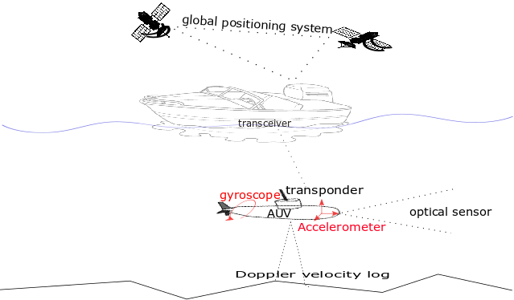

Figure 1.1 is showing the connectivity between different types of sensors which are used for underwater localization, with the help of dotted lines. The ship is connected to Global Positioning System (GPS) and AUV is connected to the transceiver of a ship through the acoustic transponder. Gyroscope and accelerometer are presented on AUV to find the linear and angular position of an underwater robot, respectively. Optical sensors or Sound Navigation and Ranging (SONAR) sensors are placed on the head of AUV which shows the front view and these can be used to find the position of a vehicle with respect to some fixed landmarks. Doppler velocity log sensor produces the velocity of an underwater vehicle which is used to find the position of that vehicle.

Underwater localization of a robot is unlike the localization in the normal territorial environment because of the rapid attenuation of noise due to the dynamic and unstructured nature of salty seawater (Paull, Saeedi, Seto, & Li, 2013). Consistent location is estimated with the help of some global and differential position measuring sensors. Global positioning system (GPS) is most commonly used for self-location discovering while some force and orientation measuring sensors are combined for speed estimation and heading correction, respectively. One major limitation for underwater localization is the unavailability of GPS (Leonard & Bahr, 2016) and other electromagnetic signal-based positioning systems e.g., cellular networks and Wi-Fi positioning systems, etc. The salty conductive nature of the sea is highly impure for the penetration of high-frequency radio signals. Similarly, with the increase in the depth, the pressure on inertial sensor produces abrupt and noisy results.

Sound waves are low frequency or high wavelength signals which can effectively penetrate through the seabed water. Most of the underwater communication is done based on acoustic waves hence acoustic positioning systems are used for localization in an underwater environment. An acoustic positioning system (e.g., ultrashort baseline, long-baseline, short baseline) results in absolute position measurement in the local environment (Rigby, Pizarro, & Williams, 2006). The connectivity of the acoustic system is shown in figure 1.1 which is between an AUV transceiver and ship transponder. Although sound traveling speed is slower as compared to radio signals but accuracy is not compromised. Delay in the acoustic positioning system can be managed with the support of the acoustic velocity sensor which works on the principle of the Doppler effect. Doppler velocity logs (DVL) sensor is an application of the Doppler effect in which the position of an agent is estimated with back-scattering acoustic waves using a dead-reckoning technique where the initial reference of the global position is required for such a sensor. There is also a network of acoustic sensors, named as Wireless Sensor Network (WSN), for which multiple algorithms are proposed to localize a robot (Tan, Diamant, Seah, & Waldmeyer, 2011).

In a spatial reference system, egocentric and allocentric techniques are used for underwater robot localization. Using the egocentric approach, the location of an agent is used as a reference for localization of other objects which can be further used for localization of secondary objects using allocentric localization methods (Al-Rawi et al., 2017). Visual positioning system provides an accurate self-location in an absolute frame of reference but with lagging efficiency due to the recognition of objects. Laser-based positioning systems with the aid of some inertial sensors have been used for location estimation in a limited sea area and shallow water.

**Figure-1.2: General idea of multisensory fusion**

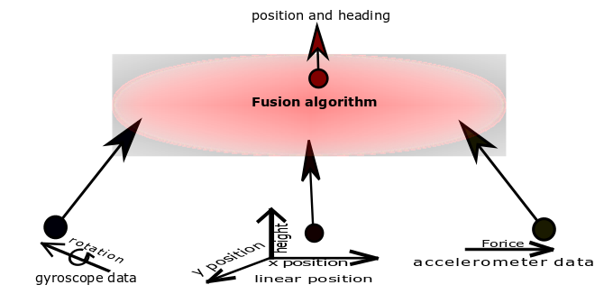

Figure 1.2 is presenting an idea to collect the data from different sensory modalities and to fuse that data of multiple sensors using a fusion algorithm to find the current position and heading of the object.

Each sensor for underwater localization has some limitations e.g., acoustic positioning systems measure the position of an agent with some delay due to the limitation of sound traveling speed and visual positioning systems are dependent on the recognition of predefined objects. Inertial sensors measure change more abruptly with the depth of water and in inverse proportion, the accuracy of velocity measuring acoustic sensors also varies with depth as they need underwater land for back-scattering of sound waves (Medagoda, Williams, Pizarro, & Jakuba, 2011). Due to the limitation of each sensor multisensory data fusion appears as a very complex and nontrivial task and it is required to estimate the optimal location of the robot which ensures redundancy resolution and better location estimation as compared to a single sensor (Rigby et al., 2006). Figure 1.2 is showing a general idea of multisensory fusion for optimal location in which different inputs are combined together and a fusion algorithm extracts useful features through it. Position, size, identity, and distance are some examples of features that can be extracted with the help of a fusion algorithm using raw input data. Specifically, in an unknown underwater environment, where there are no fixed landmarks or predefined maps to recognize the objects and to estimate the self-location of an underwater robot, the acoustic positioning systems are a better alternative than vision-based positioning systems. In conclusion, absolute positioning technologies (e.g., visual or acoustic positioning systems) and dead-reckoning technique based technologies (inertial, velocity measuring sensors) are combined to locate an underwater robot.

### 1.1: Problem Statement

The collection of exploration data in an unknown environment is meaningless when there is no known frame of reference. In the middle of the ocean, there is always ambiguity for location estimation. Radio waves cannot travel through salty water of the sea due to its conductive nature and high density. Acoustic positioning systems are the better alternative for underwater position estimation in an absolute frame of reference but results are produced with delayed measurements because of the non-linear behavior of sound in water. Similarly, vision-based positioning systems need some known objects to refer but noise impurity of water also matters. For underwater self-localization of a robot, every available sensor has limitations. Multisensory fusion is needed for redundancy resolution and optimal location estimation instead of a single sensor for localization in an underwater environment. Conventional fusion policies such as the Kalman filter can not model highly non-linear noise of the underwater environment. Multimodal hypothesis based techniques such as Monte-Carlo localization have high computational cost even in the presence of reliable sensory data. An optimal fusion policy for an underwater robot localization is required for the dynamic and unstructured nature of the seabed environment.

### 1.2: Objectives and Scope of Study

The main objective of the thesis are

To investigate available technologies and techniques of underwater localization.

* To examine state estimators and their limitations for underwater multisensory fusion.
* To analyze recent developments for underwater localization
* To develop an efficient and accurate fusion policy for optimal location estimation in a dynamic and unstructured underwater environment.

# **CHAPTER– 2**

## **LITERATURE REVIEW**

In this chapter, a very basic to advance level review is presented. Autonomous Underwater vehicles (AUV) are now converting prototypes to real working robots for scientific exploration and military operations (Mahmoud Zadeh, Powers, & Zadeh, 2019). Available technologies and fusion algorithms with their specifications are discussed below.

**2.1: Navigation Systems for Underwater Localization**

Navigation systems are divided into three main categories for underwater vehicle localization: inertial, acoustic and geo-positioning systems. In literature, these technologies have been used in various projects.

**2.1.1: Inertial or Motion Sensors**

Most of AUVs are working on the dead reckoning principle in which current change is integrated to past states for prediction of position. For underwater localization, the internal or inertial sensory information is used for prediction of location using motion estimation (Ko, Kim, & Noh, 2011). The inertial sensor incorporates error with time and produces inaccurate results. The Inertial measurement unit (IMU) is a sensor that is widely used for motion estimation. IMU contains a triaxial accelerometer, triaxial gyroscope and electrical compass for linear, angular and heading, respectively (J. Zhang, Wang, Xie, & Shi, 2014). Motion estimation below the surface of the water is not similar to the territorial environment. Inertial sensors contain unstructured noise of water which can be overcome by the modeling of the sensors (Karras & Kyriakopoulos, 2007). Modeling of the underwater sea environment is a difficult task that is why estimation of position from motion sensors becomes a crucial task. Ocean currents is a big hurdle to measure the motion of vehicle accurately so (Xie, 2016) proposed a neural network-based approach to measure three-dimensional (3D) position with a single accelerometer using a trained neural network.

For measuring the velocity of an underwater robot, DVL which is sometimes used in parallel with the IMU sensor (Lee, Hong, & Seong, 2003). DVL sensor works on the doppler principle and the velocity is estimated. DVL is more accurate in shallow water and with depth (near underwater river ground or ocean floor), its accuracy improves. In a DVL sensor acoustic signal is triggered and after backscattering the velocity of the vehicle is estimated (Dukan & Sørensen, 2013) (Hegrenæs, Ramstad, Pedersen, & Velasco, 2016) (Karimi, Bozorg, & Khayatian, 2013). In underwater, DVL is more accurate than accelerometer and its accuracy grows with depth. An accelerometer is comparatively accurate near the surface of the water and DVL is the most time accurate in deep water. DVL is an expensive sensor due to which it is not used for common projects. DVL works on acoustic waves due to which it can face variation in time of arrival. A typical working diagram of the DVL sensor is shown in figure 2.1 by (Vasilijevic, Borovic, & Vukic, 2012).

**Figure-2.1: Working principle and geometry of DVL system**

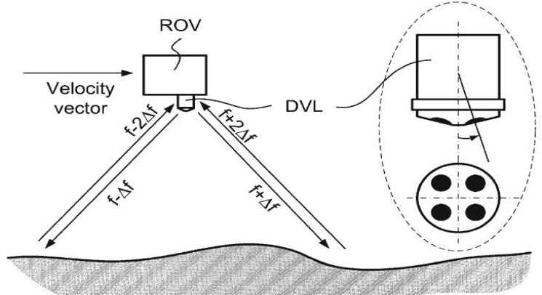

(Vasilijevic et al., 2012)

Figure 2.1 represents the working principle and shape of the DVL system which produces a velocity vector. DVL is placed at the bottom of an underwater robot. It triggers and receives the back-scattered acoustic signals to estimate the current velocity of an underwater robot. For triggering and receiving acoustic signals it has 4 windows, each with an angle of 90 degrees from others.

In an underwater environment, inertial sensors are used in both ROV and AUV but the main purpose is always motion estimation and for aid, some other sensors are also integrated with it. In (Aras, Shahrieel, Ab Azis, & Othman, 2012) for building a low-cost ROV, IMU is combined with pressure sensor and compass and this integrated sensor is tested through National Instrument DAQ for 4 degrees of freedom (DOF) in underwater. IMU is comprised of IDG500 (gyro) and ADXL335 (accelerometer) chip for linear and angular movement estimation. As the reliability of IMU varies with pressure due to which adding a pressure sensor and heading is corrected through the magnetic-resistive compass. Angle of heading is always needed to estimate the angular motion which finally helps to measure the position. In (J. Zhang et al., 2014) IMU is used for 3D location estimation of a robotic fish when the sampling rate is used as 50 Hz. DVL cannot be affected by gravity and pressure so acoustic sensors are the better choice for deep underwater odometry or velocity estimation.

In literature, IMU and DVL are integrated by various researchers considering the underwater dynamics of the sea. In (Dukan & Sørensen, 2013) DVL is integrated with other sensors using an integration filter. A DVL has 3 DOF and a 600KHz DVL, with a 7Hz ping rate, used by Dukan which covers the range of 0.7m to 90m with a standard deviation of 0.3cm/s at 1m/c. Similarly, a new generation DVL is used by (Hegrenæs et al., 2016) which is mounted in the lower part of AUV and has 500 KHz rate with 180m range, 0.2% deviation at 0.1 cm/s.

**2.1.2: Acoustic Positioning Systems**

Over time, dead reckoning based sensors accumulate the residual error and this does not remove until correction or external sensor is added. GPS doesn’t work below the surface of the water and an alternative for GPS is acoustic positioning systems. There are three types of acoustic positioning systems

* Long baseline (LBL)
* Short baseline (SBL)
* Ultra-short baseline (USBL)

**Figure-2.2: Types and geometry of acoustic positioning system**

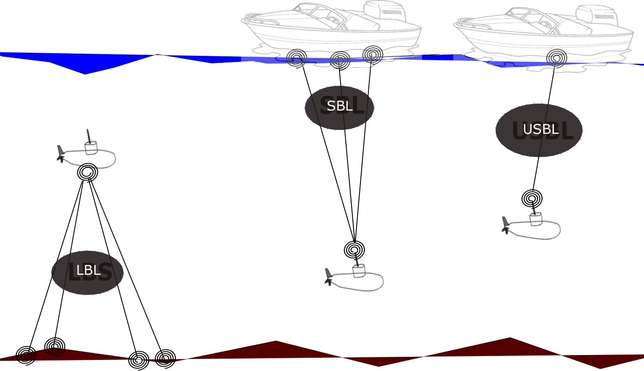

Figure 2.2 presents acoustic sensors and their geometry. LBL are fixed nodes and covers a large area for underwater robot localization. SBL uses onboard multiple transducers and one transponder. USBL uses one transducer and one transponder only and has a smaller acoustic ranging as compared to SBL and LBL.

In literature, all of these sensors have been used for various purposes. Long baseline acoustic positioning systems use 3 or 4 transponders for estimation of underwater position and are very accurate relative to the other two. When there is a system of dead reckoning sensors, such as IMU and DVL, then LBL is used as a correction sensor with the help of some fusion algorithms (T. Zhang, Chen, & Li, 2016). LBL is an acoustic sensor and underwater sound traveling is considered a non-linear system (Lawrence, 1985) which indicates that LBL itself has multiple challenges. SBL is an expensive system as compared to USBL and needs more beacons for underwater communication while USBL is used as a stand-alone position estimating system.

LBL is mostly used for underwater sensor networks and USBL has shorter ranges. Due to slower traveling speed, acoustic positioning systems have different times of arrival (TOA). Choosing a USBL in a locally unknown or featureless environment is a better choice. The propagation delay affects the accuracy of the vehicle by the addition of non-gaussian noise in USBL as well.

(Caiti et al., 2014) proposed a mixed LBL and USBL system for underwater location estimation. In the experiment, LBL is used as fixed nodes with the help of moored modems while a USBL is placed on the Typhoon AUV. IMU has a 10Hz rate and it not expensive as DVL that is why IMU is used when acoustic data is not present. LBL is a fixed acoustic nodes based system that makes an underwater sensor network. Multiple protocols are presented for underwater sensor network and various algorithms are presented for that. The review and challenges are presented in (Heidemann, Stojanovic, & Zorzi, 2012) for an underwater sensor network.

Acoustic systems have a limitation of high delays of arrival, dependency on the environment and low data rates. Sometimes abrupt noise also tempers the useful data so magnetic induction is another technique that is being considered for underwater communication (Akyildiz, Wang, & Sun, 2015). It has comparatively higher data rates but the range is no wider than acoustic position systems in an underwater environment. The magnetic induction technique is not mature enough and is not directly applicable due to the directional communication and salty conductive nature of seawater temper conductivity.

**2.1.3: SONAR and Vision-based Localization Systems**

In vision-based localization, the very first task is the recognition of the objects. In some recent advancements regarding underwater localization, the researchers have proposed various useful techniques considering the dynamics of an underwater environment. A visual odometry algorithm is developed for underwater robot localization (Alvarez-Tu, Jardon, & Balaguer, 2018) in which from the pictures features are extracted and matched for location determining. Such image-based location estimation is quite accurate although the problem we might face a delay in recognition. Different colors and intensities differentiate images and region of interest is selected by segmentation which are further used for odometry data measurement (Chen, Zhang, Dai, Bu, & Wang, 2017). Acoustic systems are considered as expensive sensors and contain non-linear noise. A monocular vision system containing a single camera is a better alternative than other positioning systems in a known and structured environment for underwater localization. Camera estimates location with the delay of recognition and it is also dependent on known objects for reference. Low cast pressure sensors and IMU are integrated with a camera to make a monocular odometry for underwater vehicles (Creuze, 2017) for pose estimation. Similarly, (Ferrera, Moras, Trouve-Peloux, & Creuze, 2019) proposed a visual odometry algorithm that is tested on different noisy images.

**Figure-2.3: Visual localization approaches**

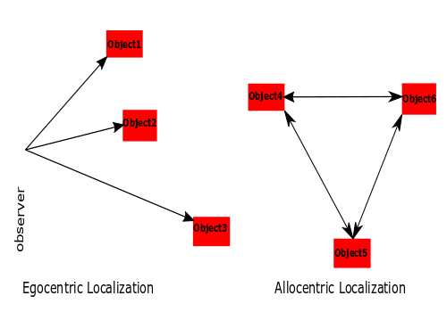

Figure 2.3 is representing the egocentric and allocentric localization concept. Robot location can be estimated online using imaging sonar which gives better position measurements than dead reckoning using DVL and gyroscope (Johannsson, Kaess, Englot, Hover, & Leonard, 2010). A SLAM with iterative closest point algorithm and regression neural network is presented in (Conte, G., 2008) to process the SONAR data without using any dynamic model in a structured environment. The horizontal error of 20 cm tolerance is done for location estimation between an agent and a recognized object. Graph SLAM in (Chen, 2015) is proposed to produce better position estimation than traditional localization methods. In simulations, the average distance error is 0.67 m as compared to dead-reckoning of 6.09 m and in the experiment, the pose error is 1.08 as compared to 7.77 m of dead-reckoning. Like a camera, there are limitations to sonar-based localization systems. The sonar-based algorithm of the self-localization of AUV is presented in (Petrich, Brown, Pentzer, & Sustersic, 2018) which is a robust technique for localization.

**2.2: Fusion Algorithms for Underwater Localization**

For underwater localization using multi-sensor fusion (MSF), various methods are discussed in (Pan & Wu, 2016) (Tan et al., 2011) (Leonard & Bahr, 2016) (Paull et al., 2013).

**2.2.1: Kalman Filter**

Kalman Filter (KF) is a stochastic filtering based state estimating algorithm that comprises prediction and estimation stages.

**Figure-2.4: Working principle of kalman filter**

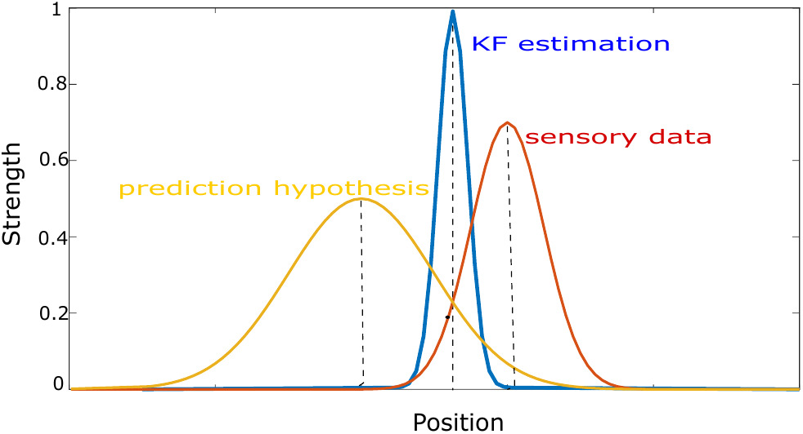

Figure 2.4 is showing the general working of the Kalman filter in which the filter gives the hypothesis of location by combining prediction hypothesis of filter and measurements of sensory data. In (Karras & Kyriakopoulos, 2007), Kalman Filter is used to fusing inertial and visual positioning sensory information for an approximation of location from a fixed earth reference but results are not satisfactory for deep water because of the addition of non-gaussian noise. A chronological linear state estimator performs poorly in presence of non-linear motion equations of the underwater environment. The underwater environment cannot be modeled using linear concepts due to which prediction hypothesis cannot be accurate and there will be no overlapping of the output of the Kalman filter.

**2.2.2: Extended Kalman Filter**

The Extended Kalman Filter (EKF) is used for converting the non-linear system to a locally linear system by involving Taylor series expansion and it is based on the "minimum mean square error" estimation principle. A general configuration of the EKF is presented in 2.5 figure. To produce a single state vector of underwater location from various sensory information, Extended Kalman filtering methods are investigated in (Ranjan, Nherakkol, & Navelkar, 2010). To somehow EKF can model some non-linear models but it increases computational cost. As seawater is highly dynamic so EKF also has limitations in underwater location estimation e.g., for underwater environment noise covariance matrix is difficult to obtain and a constant covariance matrix can not be used for dynamic scenarios.

**Figure-2.5: Typical extended kalman filter scheme**

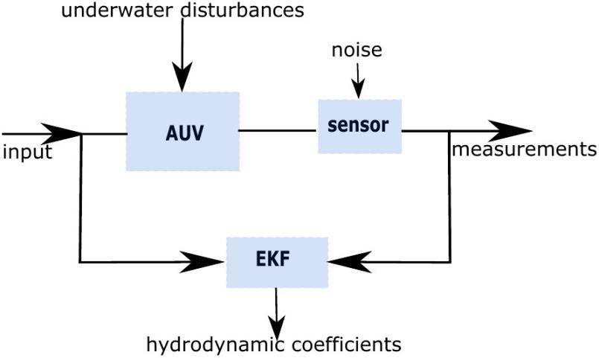

An adaptive EKF is proposed for dynamic covariance matrices in (Shao, He, Guo, & Yan, 2016) considering prior limitations. Similarly, using an online maximization estimation approach, a new adaptive EKF is presented to update noise and prediction covariance matrices for underwater vehicle localization (Huang, Zhang, Xu, Wu, & Chambers, 2017). EKF is a locally-linear model and follows Gaussian distributions. Ground speed, heading, altitude and depth are integrated using EKF by (Ribas, Ridao, Cuf´ı, & El-fakdi, 2003). In (Karimi et al., 2013) ROV is simulated for underwater localization in Matlab software in which main sensor IMU and auxiliary sensor DVL are used for motion estimation.

In (Tal, Klein, & Katz, 2017), Tal has integrated the accelerometer and gyroscope data into an inertial system which is further corrected by auxiliary sensors to feed to an EKF. EKF accurately able to find the next state and simulated environment showed that Technion Autonomous underwater vehicle (TAUV) performed better with the EKF state estimator. For a partially structured underwater environment (e.g., dams, port) EKF is used to extract the line features and AUV is localized with the help of 360-degree sonar (Ribas, Ridao, Neira, & Tardos, 2006). Two parallel extended Kalman filters are used for integrating IMU and DVL sensors and for integrating USBL and GPS for estimation of position in (Font, 2017). Furthermore, for USBL standard deviation error is 0.45 m for 100 m trajectory and using a stereo SLAM approach trajectory error bounded in range of 0 to 1.7 m for 270 m trajectory. EKF is used in (Guerrero-Font, 2016) for collecting continuous odometry data and USBL to get reliable position estimation

**2.2.3: Unscented Kalman Filter**

Unscented Kalman filter (UKF) does better approximation than EKF because it considers true deviation points and does transformation through weighted sample mean and covariance (Wan & Van Der Merwe, 2000) (Sabet, Sarhadi, & Zarini, 2014) (Allotta et al., 2016). UKF has been used for vision-based systems as well as for other sensory information fusion for underwater localization. A UKF in (Lebastard et al., 2010) is used to recognize the sphere with which reference the location of a vehicle is estimated. With the depth of the sea, the performance of each sensor varies therefore (Ko, Noh, & Choi, 2014) proposed simultaneous estimation of the pose of vehicle and depth of sea using UKF but terrain should be known. Although commonly UKF converges accurately, in case of high variance EKF is a better choice than UKF (Rhudy, Gu, & Napolitano, 2013) and accuracy of UKF improves by increasing sigma points. UKF is a non-linear model and follows gaussian distributions so it has a relatively higher computational cost than EKF. Figure 2.6 is showing the convergence of UKF and EKF which briefly describe the convergence attitude of EKF and UKF. Accuracy of UKF is better than EKF but with more sigma points the computational cost of UKF increases.

To achieve the best possible accuracy research proposed various schemes. In (W. Li, Wang, Lu, & Wu, 2013) a novel scheme is proposed in which DVL and strap-down inertial navigation system (SINS) are deployed and alignment adaptive UKF is used. UKF working is similar to a KF as both filters predict the mean and covariance before updating measurements. By using adaptive UKF measurement noise covariance is estimated hence to improve the performance of UKF which finally produces more accurate results. A navigation filter based on UKF is presented by (Allotta et al., 2015) for two Typhoon (TifOne and TifTu) AUVs. AUV offers robust behavior against different sensor configurations. It is concluded that UKF is more accurate for underwater localization and accuracy improves in the presence of USBL.

**2.2.4: Particle Filter**

In literature for underwater localization, researchers have also worked on non-Gaussian distribution. Specifically particle filter (PF) is the non-linear model which approximates noisy measurements to produce less noisy results. PF has more expensive computational cost than KF, UKF and EKF. The Kalman filter method requires a computation time of 7.956×10-5sec while the particle filter requires 4.445×10-2sec on average with the number of 15,000 particles (Kim, 2012). The motion of AUV and underwater location estimation of the acoustic positioning system are highly non-linear processes and contain non-gaussian noise so (Rigby et al., 2006) used PF for the fusion of USBL and DVL sensors. Due to multiple hypothesis particle filters gives delayed results even when there is reliable sensory data but accuracy is not compromised. (Petillot et al., 2010) Presented a method of underwater localization for AUV in the structured environment. Particle filters rely on Monte Carlo (MC) approximations in which a large number of particles are distributed for achieving massive accuracy. The MC localization consists of two stages as the usual Bayes filters. The first stage predicts the location of an underwater robot using onboard sensory data such as IMU, DVL, etc. The second stage corrects the predicted location using external information such as USBL and DGPS. The results in (Kim, 2011) show that it is possible to estimate the robot location in 3D space using only two acoustic beacons.

**Figure-2.6: Comparison of unscented transform (UT) and EKF**

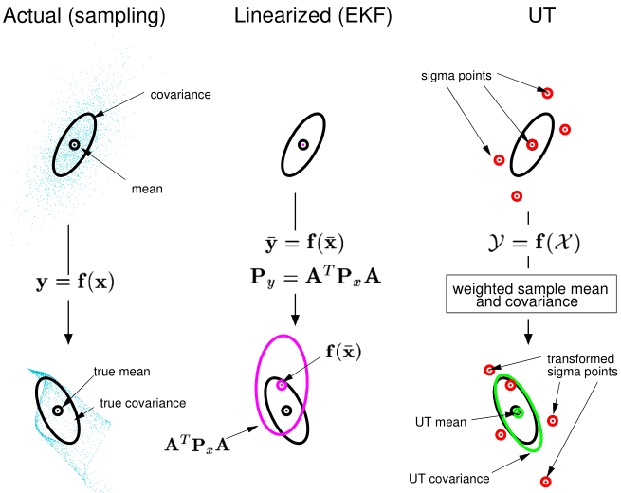

(Wan & VanDer Merwe, 2000)

In (Mandic, Renduli c, Mi skovi c, & Na, 2016), the OWTT-iUSBL system uses a known waveform which is triggered by a beacon that is present at the known place. AUV captures the signal with the help of the Tetrahedral Hydrophone array. The Particle filter is used which obtain the information from sensor data and fuse it with the motion model. It is proposed that particle filter produces more accurate trajectories for AUV. Most of the underwater simultaneous localization and mapping (SLAM) work is done using a particle filter. Guillem (Vallicrosa & Ridao, 2018) has used particle filter for state estimation of AUV Virtual and real environment. The proposed technique is capable of running online and represent the environment more accurately.

|  |  |  |  |  |
| --- | --- | --- | --- | --- |
| Table-2.1: Comparison of Conventional State Estimators for UWL | | | | |
| **Filter** | **Working principle** | **Model** | **Computational cost** | **Distribution** |
| KF | Unimodel hypothesis | Linear | Low | Gaussian |
| EKF | Taylor series expansion | Locally linear | Low - medium | Gaussian |
| UKF | Sigma point distribution | Non-linear | Medium | Gaussian |
| PF | Multi-model hypothesis | Non-linear | High | Non-Gaussian |
|  | | | | |

Table 2.1 describes the specifications of the different conventional filters used for underwater localization. As Kalman filter deals with a linear model, it has a low computation cost and its distributions are gaussian type. Similarly, EKF and UKF follow gaussian distributions but somehow they can deal with non-linear systems. Particle filter best fits for dealing non-linear systems with a multi-model hypothesis but it has a high computational cost.

**2.2.5: Machine Learning Methods**

Machine learning methods are preferred to deal with highly non-linear systems, nowadays. The main focus of researchers for underwater localization is to use neural networks. Least squares regression formulation presented in (Dellaert & Kaess, 2006) saves the past states for posterior state estimation and is a better scheme than the Extended Kalman filter for underwater localization. Chame (Chame, Dos Santos, & da Costa Botelho, 2018) proposed the principle of contextual anticipation in which, with every coming reliable measurement of global sensor, the anticipation span resets to overcome abrupt noise. This anticipation span can neglect the unexpected noise of a global positioning sensor but there is still massive noise of inertial sensors. Sabra (Sabra & Fung, 2017) proposed a novel underwater localization scheme called Best Suitable Localization Algorithm (BSLA). BSLA dynamically fuses multiple position estimates of sensor nodes using a fuzzy decision support system of selecting a suitable algorithm.

For a single onboard vehicle, one approach to overcome noise is through modeling of non-linearities by supervised learning (Fang, Wang, & Fan, 2019) but this is suitable where the system repeat patterns and task conditions remain almost similar between training and execution time. To identify the reliability of acoustic positioning sensor is the main challenge for the autonomous underwater vehicle because of long delaying in its measurements (Gopalakrishnan, Kaisare, & Narasimhan, 2011). Sonar or other vision-based sensors sometimes give delayed measurements due to various signal processing reasons. Time delaying estimation is made in (Houegnigan et al., 2017) where a neural network is used to estimate the possible delay of acoustic positioning sensor for more consistent results.

**2.2.6: Bio-inspired Approaches**

Some bio-inspired work is presented demonstrating the location estimation just like a fish senses the flow rate under the water and using the predefined map the location can be estimated (Muhammad, Toming, Tuhtan, Musall, & Kruusmaa, 2017). Similarly based on mammals navigation Dolphin SLAM (Silveira et al., 2015) approach is presented which is an appearance-based localization method and in contrast to probabilistic methods low-resolution sonars and images can be used for underwater localization. Synchronous and asynchronous comparison for underwater robot localization is presented in (Ko, 2016) where the simulations and experimental results are in statistics for a vehicle to travel from one point to another in 3D space.

Based on key information extracted from the camera and IMU, a Monte Carlo Localization(MCL) algorithm is established to localize the robotic fish. The image processing algorithm is used to estimate the distance and angle between the robot and the landmark (Zhang, 2014). Odometry is generated for the robot based on the data of IMU. From the experimental results, it can be concluded that the proposed localization approach can localize the robotic fish quickly and accurately.

s

# CHAPTER- 3

## RESEARCH METHODOLOGY

The location of exploration data is meaningless without a reference of known location and the underwater environment is highly nonlinear. Various methods are employed for the purpose of locating an underwater vehicle for the structured and unstructured environment but available techniques are either not able to predict underwater location accurately or have high computational cost. The main challenge for underwater localization is to predict underwater location accurately in an optimal way. A novel neural network-based technique is proposed in which weights are set intuitively. Each sensory information is encoded into a gaussian format and it is processed through the filter of equidistant weights. The proposed method not only predict individual sensory information with accuracy but it also fuses the sensory information of global and inertial sensor. The general idea of the proposed neural network is presented in 3.1 figure. The proposed Perdictive Coding Biased Competition Decisive Input Modulation (PC/BC-DIM) neural network and simulations are described in the sections below.

### 3.1: PC/BC-DIM Neural Network

PC/BC-DIM is a hierarchical neural network in which predictive coding (PC) (Huang & Rao, 2011) is made compatible with Biased Competition (BC) (Spratling, 2008) and that is implemented using Divisive Input Modulation (DIM) (Spratling, De Meyer, & Kompass, 2009). A processing stage of the network is made up of three different neuron populations. The functioning of each neuron population is expressed in 3.1, 3.2 and 3.3 equation.

|  |  |  |
| --- | --- | --- |
|  |  | (3.1) |
|  |  | (3.2) |
|  |  | (3.3) |

where x, e and r are input vector, error and reconstruction neuron activation functions respectively having the size of m by 1 for each. y is a vector of prediction neuron activations having the size of n by 1. W is a matrix of feed-forward synaptic weight values with the size of n by m and V is the normalized transpose of W. The mathematical operators are used for point to point multiplication and division respectively. The value ofis  in order to prevent prediction neurons from becoming non-responsive and it also sets the baseline activity rate of prediction neurons. The value of is  in order to prevent division by zero and determines the required minimum strength of input to affect the response of prediction neurons. Prediction neurons activation (y) are initialized with small random values or with zero values. The PC/BC-DIM network iterates for a number of iterations to determine the stable response of each neuron population activation.

**Figure-3.1: PC/BC-DIM processing stages**

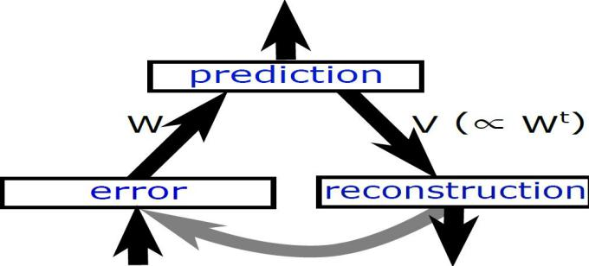

The input of PC/BC-DIM network is termed as causes that are encoded into useful information. Every new input plays a role in the training of weights. Adding up the same sensor input not only increases the size of weights but it also consumes more computation and makes the network process slow down. To overcome this situation, the proposed network can be trained on the explaining away pattern of reasoning in which the same sensor input is not required and only different information from weights is considered to update the weights. The values of y are prediction points for distinct causes and expected input is obtained under these prediction points. The difference of reconstructed input r and actual input x is represented with e. Weights W is the most important part of the network because it sets the possible range of causes. Each row of W is like a basis vector or elementary component of the whole system. The divisional approach is considered to minimize the error in PC/BC-DIM network instead of a subtractive method as the subtractive method converges to the solution more slowly and a solution is less sparse furthermore subtractive method is less biologically plausible.

**Algorithm-3.1: ActivationPCBC(x,W)**

1: **for** i = 1:iterations

2: r = V*y

3: e = x ./ (e2 + r)

4: y=(e1+y).*(W*e)

5: **end**

PC/BC-DIM can perform computations with probability distributions when input is a probability function. Weights are the elementary components so every specific input can be reconstructed from these weights. PC/BC-DIM can reconstruct noiseless signals. Figure 3.2 shows that how a noisy causes reconstruction through the PC/BC-DIM neural network.

**Figure-3.2: PC/BC-DIM noisy input reconstruction**

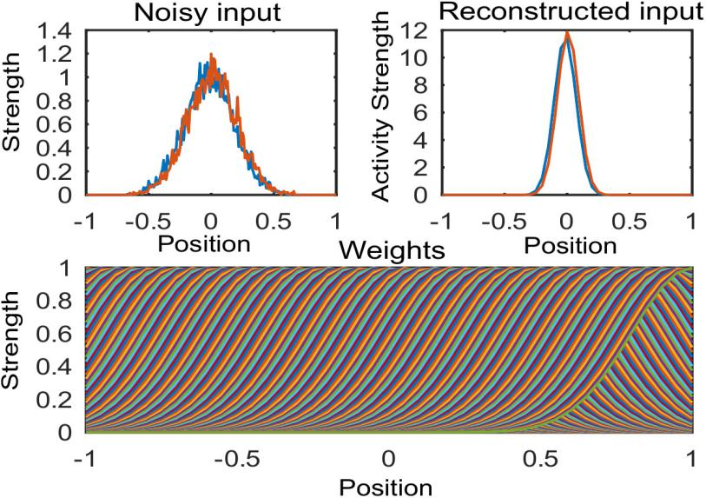

Sensory measurements of an underwater robot are just discrete values of position and they are mixed with an abrupt and non-gaussian type of noises. Weights are considered as a modeled system that is why input stimulus decides the nature of weights of the network. PC/BC-DIM network weights are set intuitively and less noisy reconstructed results are obtained using noisy sensory data. The input of sensors can be encoded in various formats and to encode them into probability density function one-dimensional gaussian equation is presented in equation 3.4 below.

|  |  |  |
| --- | --- | --- |
|  |  | (3.4) |

A single dimensional gaussian encoded input is used to set a weight vector in W weight matrix until the training of weights is completed. For a trained network encoded input is processed from the network for some number of iterations. For a medium-sized network, 25 numbers of iterations are enough to produce a stable reconstructed input. Reconstructed input can be decoded back with the help of following equation:

|  |  |  |
| --- | --- | --- |
|  |  | (3.5) |

where μ is the mean value of probability density function (PDF) where zi is the activation of neuron I and si is a receptive field (RF) of neuron i. Similarly, the variance can be calculated using the equation below

|  |  |  |
| --- | --- | --- |
|  |  | (3.6) |

The filter can combine the likelihood of the prior to calculate the posterior probability. Fusion or integration of multiple causes is another ability of the filter.

**Figure-3.3: PC/BC-DIM working principle**

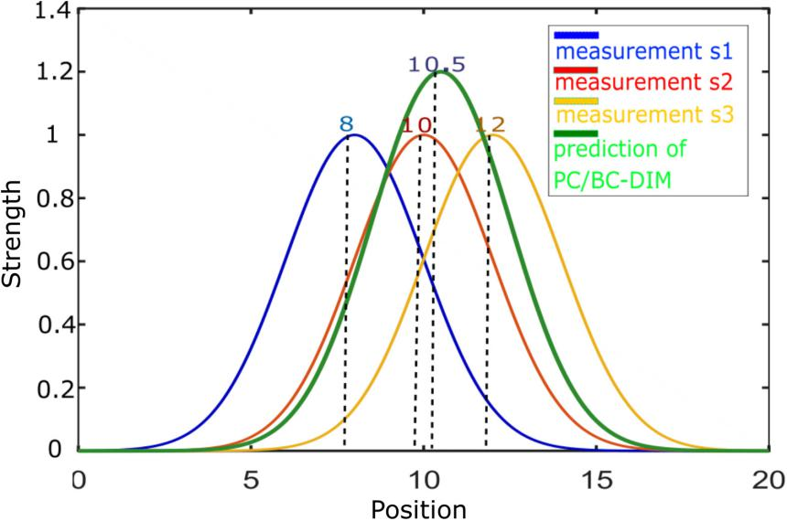

**3.1.1: Training of Weights**

In a neural network, the main part is always training the weights. In PC/BC-DIM input makes the weights so weights are like the dictionary for all possible inputs. One way to train the weights is to store non-noisy different types of inputs in a matrix form but for underwater localization, weights are intuitively set for convenience to observe the performance of the network. Suppose there are 4 types of input and they are named as IMU, DVL, USBL and DGPS. The weights for all sensors are shown in the 3.4 figure. In simulations, all weights are concatenated like all sensors and reconstructed input r is obtained.s

**3.1.2: Multisensory Data Fusion**

In real-time experiments, there are always multiple sources of information about the same sensory stimulus. This sensory information can be obtained from the same sensory modality or different sensory modalities for the same task. The purpose of multisensory fusion is to determine a single estimate for a different type of information obtained from different sensor modalities. For example, human performance in cue integration is optimal as it can use different sensory information for the same task by considering the reliability of every cue. PC/BC-DIM has the ability to optimally integrate these sensory modalities. Figure 3.5 is demonstrating the integration of two sensory cues that are present at a different location. Their weights, actual input, prediction neuron and reconstructed input is mentioned.

**Figure-3.4: Trained weights of multiple sensors**

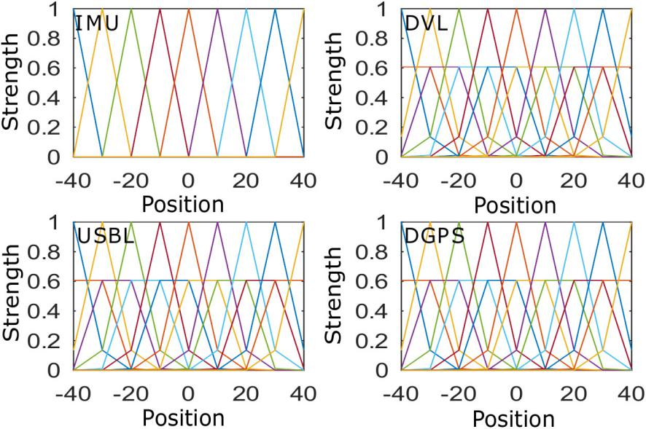

**Figure-3.5: Fusion of two types of sensory inputs**

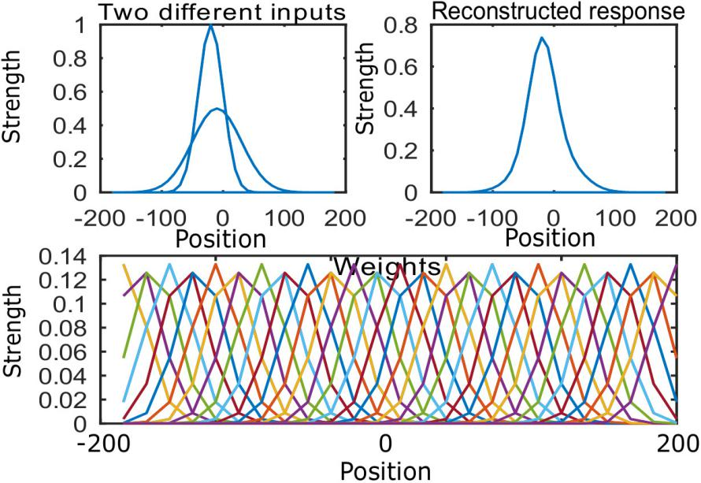

### 3.2: PC/BC-DIM Neural Network for UW Localization

To localize an underwater robot motion sensors and absolute positioning sensors are used. Each sensory data is first encoded into the individual probability density function (PDF) and these concatenated encoded inputs are processed from PC/BC-DIM neural network to achieve the best possible single probability density function as reconstructed input r. This reconstructed input r is decoded using the equation to find a single mean value which indicates the optimal position. For that purpose mean and variance of each sensor is required to be found. The mean value is selected as the actual measurement of the sensor and variance is a possible range of that sensory value. Each encoded sensory data has the size of (m by 1) while after combining all sensors the data will be a vector of size (N times m by 1), where N indicates the number of all sensors. Amplitude and deviation of each encoded input are the same as weights of respective input.

**3.2.1: Sensors for Simulations**

One-dimensional and same nature of information (e.g., position, heading, etc) is processed from the filter at a time. In the implementation section IMU, DVL, USBL, and DGPS systems are used to estimate the location of AUV. IMU and DVL are dead-reckoning sensors that is why they have to integrate previous states to estimate the current state. USBL and differential Global Positioning System (DGPS) result in an absolute location of an autonomous underwater vehicle.

GPS doesn't work below the surface of the water but has a fine accuracy above the surface of the water. USBL is an alternative of GPS that can work below the surface of the water. Absolute location points of UAV can be located with the help of USBL but there is always delay in the time of arrival acoustic signal. Other than having a low data rate the USBL also contains noise due to disturbances caused by the underwater environment. As support, some dead reckoning sensors are added in which IMU is a very well known sensor. So collectively the unavailability of a low rate positioning sensor in an underwater environment is aided with the help of IMU and DVL.

Dead-reckoning sensors specially IMU contains nonGaussian noise in an underwater environment. From IMU the position of an underwater vehicle is derived by double integration of accelerometer data. IMU can not completely estimate the position of an underwater vehicle due to the presence of underwater noise. For redundancy resolution and improving accuracy, the DVL sensor is added in parallel to IMU. DVL is more accurate in shallow water, but in deep water, it has concerns as well because the velocity of the underwater robot is estimated with the help of backscattering acoustic signals. These acoustic signals trigger from the underwater robot and after backscattering from the earth below the surface of water these signals help to estimate the velocity of AUV. To estimate position adding up previous states to current state produces a residual error which can be corrected by positioning sensor.

**3.2.2: Encoding of Sensors**

Every sensor has either limitation of reliability or accuracy so that each sensor is encoded with different variance and the maximum peak value of every encoded sensor is one. Figure 3.6 is showing the 5th value of all sensors. Equation 3.4 is used for encoding each sensory input. One point to note is that exact real measurements of sensors are not directly used. The encoded input is processed from PC/BC-DIM neural network and reconstructed output will return the exact location. Each sensor is concatenated to a single vector before processing from the network. The equation of sensor encoding has three main parameters of inputs, centers and standard deviation.

|  |  |  |
| --- | --- | --- |
|  |  | (3.7) |

Range is the distribution of inputs and c is center or mean of respective input. s is the deviation of input and A is amplitude which is set equal to 1.

**Figure-3.6: Encoding of sensory data**

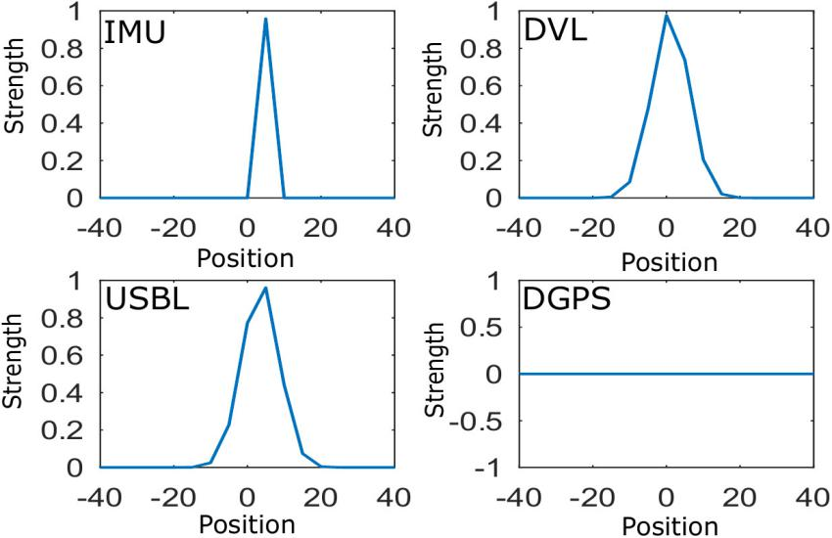

**3.2.3: Decoding of Reconstructed Input**

With the help of the decoding equation, the mean values of reconstructed input are selected. PC/BC-DIM is not only reconstructed each input but it also fuses multiple sensory data. Reconstructed input can return diversity in results based on experience because of the deviation of each sensor and weights. If the range is selected from 0 to 40 with the difference of 10 and sigma is selected as 1 then the output will saturate on the multiple of 10s (e.g.,0,10,20,30 and 40). With the increase in the variance of sensor and weights, the distribution of output will scatter. The value of reconstructed input also depends on the shape of the weights. If prior information of specific type is available then reconstruction of input will be according to that likelihood.

**3.3: Algorithm of PC/BC-DIM for Underwater Localization**

Generally, there are two types of sensory information available. One is inertial or motion data and second is global fixes information. For global or absolute position estimation, the difference of last position (during the presence of global position) from the current position is fed to the PC/BC-DIM network. Inertial sensors are integrated until global fixes correct the residual error of the dead-reckoning sensor and then these are reinitialized to zero. The algorithm is presented below for an underwater robot localization using PC/BC-DIM neural network. W_i are weights of inertial or motion sensor and W_g are weights of global sensor which are concatenated and stored in W synaptic connection weights. Mval_g is an input of the global sensor and Mval_i is inertial input. Until the last value of the sensor, the filter consistently updates multiple sensory inputs with a single reconstructed response r. Inertial values are accumulated with previous values and global value takes the difference of last value as sensory input. If there is no value present for any sensor then encoded input is assigned with zeros. x is concatenated input and r is reconstruction response. Location is determined by the decoding r response.

In algorithm 3.2 first weights are trained then inertial sensory data is accumulated until the positioning data comes. When any positioning sensor measures location then the current position of the sensor is subtracted from the decoded position. This decoded position is the value of decoded PC/BC-DIM filter on the arrival of the last positioning data. Accumulated inertial measurement resets to zero when a change of position is processed with it from PC/BC-DIM filter. When positional data is not available it is encoded with zeros of the same size.

**Algorithm-3.2: Underwater Robot Localization using PC/BC-DIM Algorithm**

1: W = [W_g W_i]

2: [n , m] = size( W )

3: y = zeros( 1 , n )

4: Mval_g = reference

5: Mval_I = reference

6: tempPos = reference

6: **while** val = FinalValueSensor **do**

7: **if** val_i is present then

8: Mval_i = decoded_Pos + val_i

9: x_I = Gaussian(Mval_i)

10: **else**

11: x_i = zeros( 1 , m / size( sensors ))

12: **end if**

13: **if** val_g is present

14: x_g = Gaussian( val_g - last_g)

15: **else**

16: x_g = ( zeros(1 , m / size ( sensor ) )

17:  **end if**

18: x = [ x_g x_i ]

19: r = ActivationPCBC ( x ; W)

20: decoded_Pos= decode(r( 1 : length( xGlobal ) ) )

21: **if** sum(xGlobal) != 0 then

22: last_g = decoded_Pos

23: decoded_Pos = 0;

24 tempPos += decoded_Pos;

25: **end if**

26:position = [position tempPos+decoded_Pos]

27:**end while**

# CHAPTER- 4

## RESULTS AND DISCUSSION

In this chapter simulations and experimental results are discussed. As support of the proposed method, some basic trajectories are presented with noisy positions. Using PC/BC-DIM the noise is reduced and a very closer trajectory to the actual noise-free or ground truth trajectory is obtained.

**4.1: Execution of PC/BC-DIM for localization:**

For horizontal coordinate cosine function and for vertical coordinate sine function is selected with the parameter t from 0 to 2π. By setting x=cos( t ) and y=sin( n * t ) multiple shape trajectories are obtained with n integer values. For circle equation n=1 and in the following cases a different type of noise reduction using PC/BC-DIM will be discussed.

**4.1.1: Random Noise Addition:**

First, a circle is made by equation x=cos( t ) and y=sin( t ) where t has 500 values from 0 to 2π. Here, x and y represent the ground trajectory without any noise. Random noise is added to this trajectory to make noisy GPS values according to 4.1 and 4.2 equations. Noise is product of noise constant and random numbering from 0 to 1. Green points in figure 4.1 represent the noisy GPS points and noise constant is 0.1 for GPS positioning points. The first and last element of x and y is the starting and ending point it trajectory, respectively. The Red line is showing the outcome of decoded values of the PC/BC-DIM neural network.

|  |  |  |
| --- | --- | --- |
|  | x_gps = x + noise | (4.1) |
|  | y_gps = x + noise | (4.2) |

Sigma of PC/BC-DIM inertial inputs and weights is 10 and for global inputs and weights, sigma is 5. The range and centers are set -5 to 5 with the difference of 2. As in this case, there is only noisy position and no inertial sensory data is made so only a previous decoded position is fed to the network. Figure 4.2 shows the output against noise constant 0.2 for GPS points. This shows that with a very high noise still the PC/BC-DIM is producing closer results to the ground noise-free trajectory.

**Figure-4.1: PC/BC-DIM outcome for noisy positioning points**

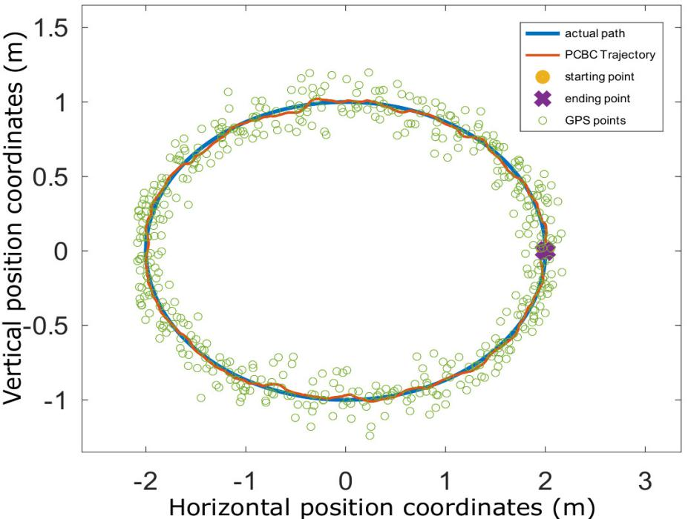

With the experiment, it is observed that by increasing the number of positioning points the trajectory of the PC/BC-DIM neural network improves.

**Figure-4.2: PC/BC-DIM outcome for 2 times noisy positioning points**

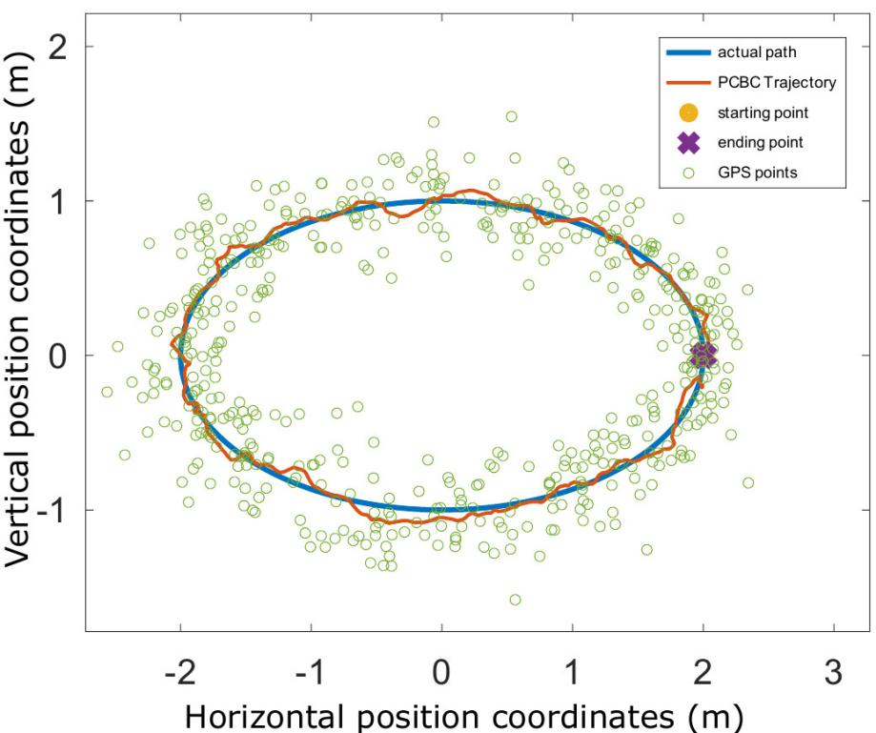

**4.1.2: Non-Gaussian or Abrupt Noise Addition:**

Abrupt noise is the common problem of the ultrashort baseline sensor and it is observed that this noise is overcome by PC/BC-DIM using a defined approach. To demonstrate this problem random high noise is added at different indexes of noisy GPS signals. Range and centers are set -2 to 2 with the step size of 0.1 while sigma of inertial and global input is set as 1. It is already mentioned that when there is no inertial sensory data available then the last decoded position of the global sensor is used instead of it. Figure 4.3 is showing the abrupt noise at different indexes of the y_gps axis. In the described approach if the change goes beyond the range then it is ignored by the neural network and previous decoded input is used instead of noisy values as GPS is showing in its trajectory.

**Figure-4.3: PC/BC-DIM outcome for non-gaussian or abrupt noise**

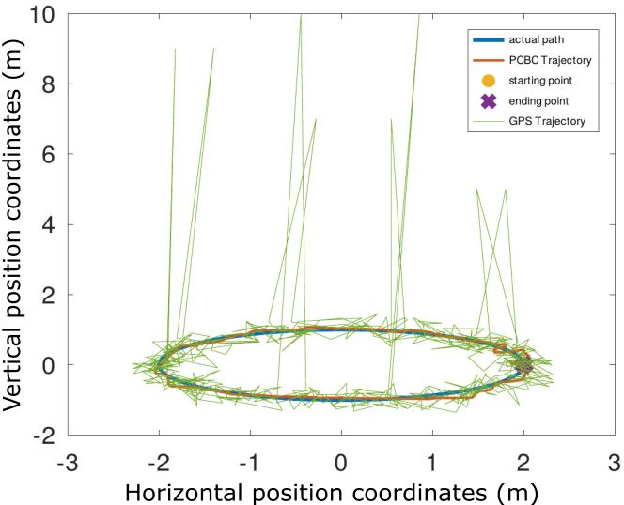

**4.2: Simulation Data Comparison with a B-PR-F Neural Network:**

Behaviour Prediction Reliability Fusion (B-PR-F) proved that it is better than Kalman filter, Extended Kalman filter and Monte Carlo methods while our proposed PC/BC-DIM neural network produces more accurate results than the B-PR-F neural network. We used the same sensory data and the same simulation environment for testing the PC/BC-DIM neural network. IMU is highly noisy sensory data and using only IMU with USBL and DGPS the proposed PC/BC-DIM neural network produces better results than 4 sensory data of B-PR-F neural network. Similarly, individual DVL with USBL and DGPS produces better approximation. A detailed comparison is presented in sections below.

**4.2.1: PC/BC-DIM and B-PR-F Comparison:**

The simulations are conducted in an open-source software named as GNU Octave. Before making a comparison, some information about the data is required. For comparison purposes, it is necessary to use the same sensory data for both filters. Detailed information of sensory data is available in appendix A of (Chame et al., 2018) in which a ground truth (GT) is the actual noise-free trajectory. Sensory data of simulations include IMU, DVL, USBL, DGPS and Altimeter. Altimeter sensor is not used as a proposed filter gives optimal location without any manual switching. IMU data is simulated by twice the differentiating and adding noise to it so integrating the measurements diverge from the original trajectory. Similarly, DVL is one time differentiated and noise is added that is why it is relatively accurate than IMU. From reference GT trajectory with the equal time difference, various points are selected and in those selected points two types of noise are added to achieve USBL like sensory data. Noise 1 is random noise at all points which has a higher scale in deep water and noise 2 is highly non-gaussian abrupt values at some indexes. DGPS works fine above the surface of the water so for a few seconds similar GT values are selected for DGPS sensory data.

**Figure-4.4: B-PR-F neural network results**

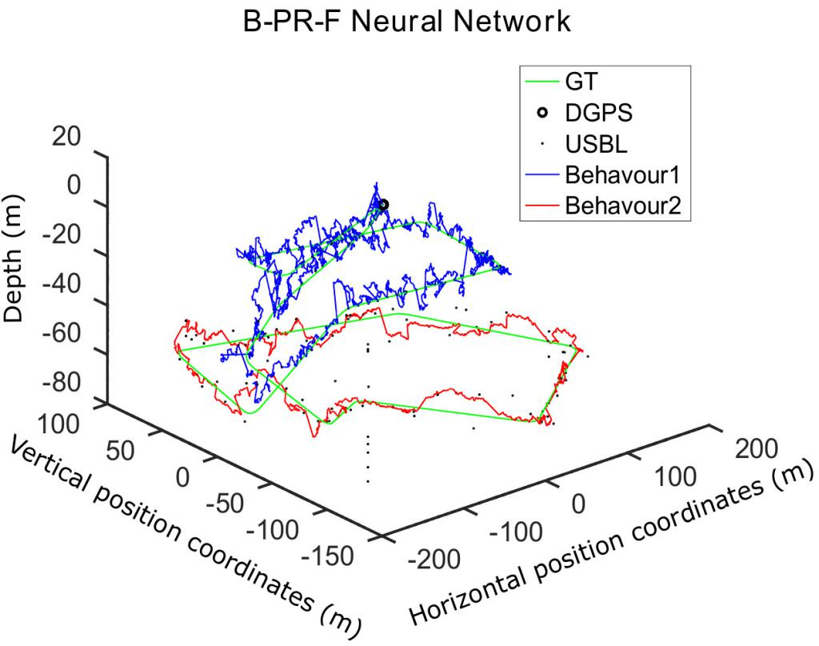

Range of -40 to 40 with the difference of 5 is selected and centers are set using the same configuration. Sigma of DGPS is set equal to step size 5, sigma of USBL is selected 8.5 while both of dead-reckoning method based sensors (DVL and IMU) have 10 of sigma to achieve optimal position estimation. Iterations for PC/BC-DIM are set as 35.

**Figure-4.5: PC/BC-DIM neural network results**

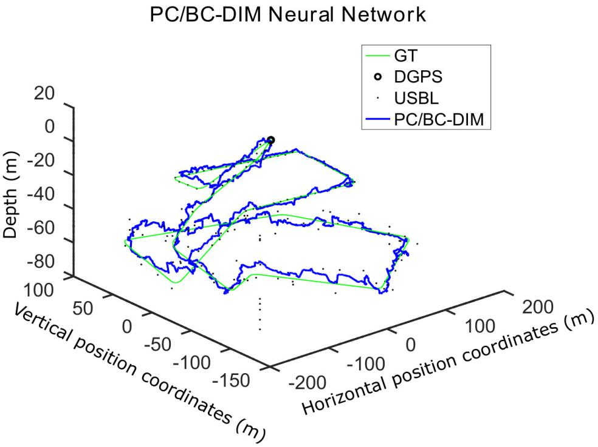

Above figures 4.4 and 4.5 are demonstrating the visual difference between two filters using the same sensory data. PC/BC-DIM is returning more converging and smooth results. B-PR-F has two behavior of deep and near-surface while PC/BC-DIM has an optimal attitude without any manual switching of any sensor. The green trajectory is showing ground truth data.
Statistical comparison gives more clear differences. Table 4.1 shows the differences

|  |  |  |  |  |
| --- | --- | --- | --- | --- |
| Table-4.1: PC/BC-DIM and B-PR-F Simulation Comparison | | | | |
| **Filter** | **Mean Sq Error** | **std Error** | **RMS error** | **Time of execution(s)** |
| P-PR-F | 51.078 | 2.0788 | 6.8385 | 15.612 |
| PC/BC-DIM | 18.790 | 1.761 | 3.9618 | 20.351 |
|  | | | | |

**Figure-4.6: Error comparison for both neural networks**

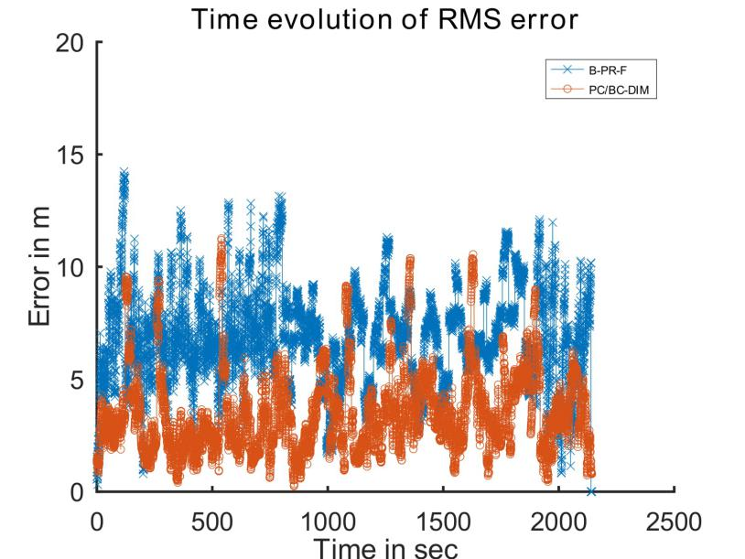

Figure 4.6 is representing the difference between the Root Mean Square (RMS) error of both neural networks. The spikes in PC/BC-DIM can be improved further by increasing the iteration but a minor computation cost will increase..

**Figure-4.7: Depth coordinate of B-PR-F neural network**

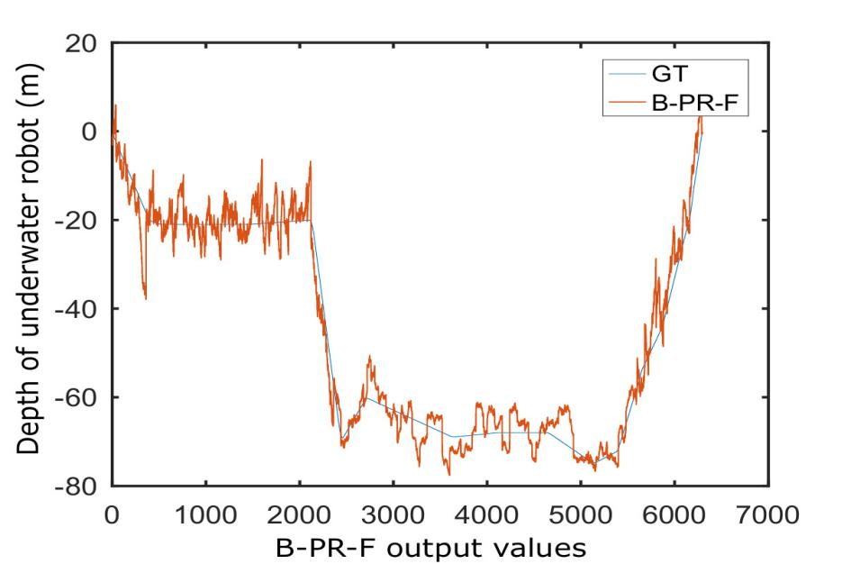

For more clear visualization figure 4.7 and figure 4.8 are representing depth coordinate comparison with the GT depth coordinate.

**Figure-4.8: Depth coordinate of PC/BC-DIM neural network**

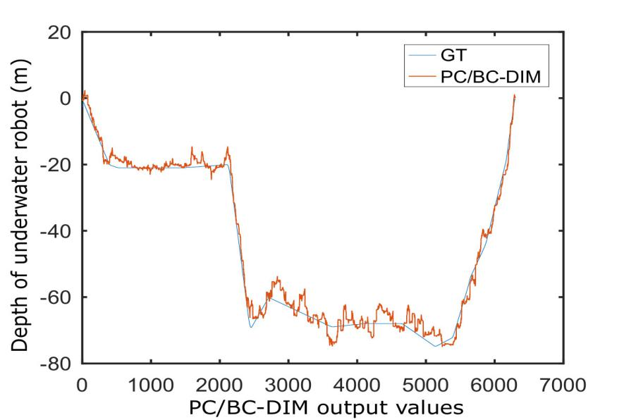

Figure 4.8 is showing less noisy depth coordinate of the PC/BC-DIM neural network as compared to the B-PR-F neural network. Both neural networks are removing noise of the USBL sensor but PC/BC-DIM is not only eliminating non-gaussian noise but it is also producing smooth and less noisy trajectory as in figure 4.9 presented.

**Figure-4.9: Noisy USBL vs PC/BC-DIM results for vertical coordinate**

|  |  |
| --- | --- |
| *figure4.6* | *figure4.7* |

**4.2.2: All Sensors B-PR-F and without IMU PC/BC-DIM Comparison:**

PC/BC-DIM can give better results without using the IMU sensor and by relying only on the DVL sensor. USBL, DGPS and DVL can produce better results than B-PR-F filter in above and below the surface of the water. The same process and same sigma values of all sensors are selected which was selected for the 4.2.1 section.

|  |  |  |  |  |
| --- | --- | --- | --- | --- |
| Table-4.2: PC/BC-DIM and B-PR-F Simulations W**ithout IMU** | | | | |
| **Filter** | **Mean Sq Error** | **std Error** | **RMS error** | **Time of execution(s)** |
| PC/BC-DIM | 12.346 | 1.5701 | 3.1441 | 19.979 |
|  | | | | |

**4.2.3: All Sensors B-PR-F and without DVL PC/BC-DIM Comparison**

PC/BC-DIM can give better results by relying on only IMU and excluding the DVL sensor where IMU is the highly noisy sensor. USBL, DGPS and IMU are feed to PC/BC-DIM neural network and it has presented lesser trajectory error as compared to the B-PR-F neural network.

|  |  |  |  |  |
| --- | --- | --- | --- | --- |
| Table-4.3: PC/BC-DIM and B-PR-F Simulations (**without DVL)** | | | | |
| **Filter** | **Mean Sq Error** | **std Error** | **RMS error** | **Time of execution(s)** |
| PC/BC-DIM | 21.857 | 2.0636 | 4.196 | 19.979 |
|  | | | | |

**4.3: Experimental Data Comparison with a B-PR-F Neural Network:**

In this experiment, the vehicle traveled for 61 minutes to cover 693 meters of distance. The method is proposed for the estimation of the 2D location of the vehicle on the surface of the water. The location is estimated using low rate absolute positioning data and high rate relative positioning data. In an open environment, DGPS is very accurate above the surface of the water so it is treated as ground truth with its 3662 positions. For the absolute location estimation, 1450 positions of Ultrashort baseline (USBL) are measured and for relative position measurement, 19992 grayscale images of 16 bit are taken by SONAR. SONAR images are converted to useful odometry data to find a change in angle and to get change in images frames.

To process the information from the filter to obtain the optimal position motion vector (Δx , Δy) and positioning vector (x , y) is needed. Detailed information of sensory data is available in appendix B of (Chame et al., 2018) in which for motion estimation scan matching method is used to obtained motion data along the horizontal and vertical coordinates. An angle is needed for motion estimation as the correct motion of Δx and Δy is obtained from the following 4.3 and 4.4 equations. USBL data is used as a positioning sensor.

|  |  |  |
| --- | --- | --- |
|  |  | (4.3) |
|  |  | (4.4) |

Where theta is the current angle or heading of the vehicle. Compass has measured 4357 heading angles. When compass sensory data is not available then partial theta of odometry data is used to correct the angle with the following equation 4.5 and each angle is wrapped to 2π using octave mapping package.

|  |  |  |
| --- | --- | --- |
|  |  | (4.5) |

|  |  |  |  |  |
| --- | --- | --- | --- | --- |
| Table-4.4: PC/BC-DIM and B-PR-F Experiment | | | | |
| **Filter** | **Mean** | **Std. Dev.** | **Time (sec)** | **Reference** |
| Dead reckoning | 45.7573 | 26.9248 | 12.8949 | Chame (Chame, Dos Santos, & da Costa Botelho, 2018) |
| Kalman Filter | 1.9479 | 3.0804 | 13.5013 |
| MCL (using PF) | 1.5968 | 1.2146 | 156.1984 |
| KF Post Processing | 1.4568 | 1.6161 | 13.2737 |
| B-PR-F | 1.4139 | 1.1479 | 46.9161 |
| **PC/BC-DIM** | **1.3526** | **1.0412** | **45.2462** |  |
|  | | | | |

**Figure-4.10: B-PR-F position estimation**

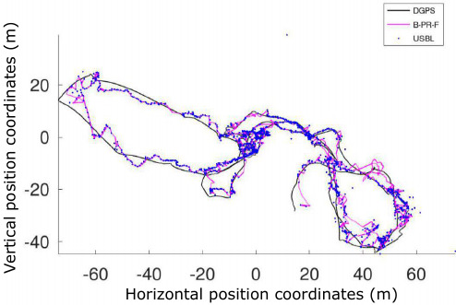

The plotting of experimental results provides a clear difference between the B-PR-F and PC/BC-DIM neural network estimations.

**Figure-4.11: PC/BC-DIM position estimation**

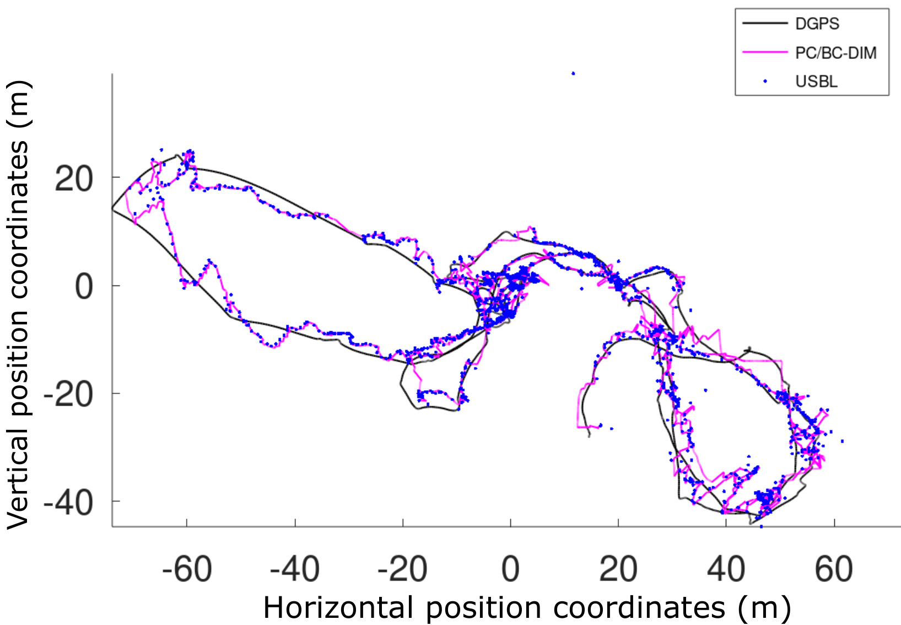

Range of -14 to 14 with a difference of 1 is selected and centers are set using the same configuration. Sigma of USBL is set equal to step size 1 and the sigma of motion estimation vector is selected 3.5 to achieve optimal position. The iterations are set 35 for the PC/BC-DIM neural network.

# CHAPTER- 5

## CONCLUSIONS AND DISCISSION

Water covers more than 70 percent of the earth’s crust and there is a green area for searchers to discover and explore underwater resources. The collection of exploration data is meaningless when the location of an underwater vehicle is not known. GPS and other radio signals do not work below the surface of the water. As alternative acoustic positioning systems are used but they have low data rates and non-Gaussian noise in their measurements. To make underwater localization more reliable some motion estimation sensors are added e.g., IMU, DVL, odometry. IMU works normally above the surface of the water but its noise temper the motion estimation measurement with the increment of the pressure of the sea. DVL works better in deep water near the seafloor. This all indicates to use a multisensory fusion technique to make a single underwater robot that can estimate the location of the vehicle both above and below the surface of the water. Conventional fusion policies either have low accuracy or high computational cost. Kalman filter is not as accurate for non-linear noise and not smart enough to ignore the non-Gaussian noise. Extended Kalman filter can convert the non-linear system to the locally linear but still underwater sensors are highly unpredictable. Monte Carlo Particle filter can deal with underwater noise by multiple hypotheses but it makes the localization process slow even there is less noisy data. Recently Chame proposed the principle of contextual anticipation which resets in the presence of reliable sensory data of USBL and when an unusual measurement of USBL produces then his proposed B-PR-F ignore this unreliable value. Sabra proposed that it is better to use different techniques for different environments. This environment is treated with neural networks because they are very modern methods to model non-linearities. PC/BC-DIM neural network is proposed for localizing the vehicle below the surface of the water. Weights are set according to the nature of sensory data and position is estimated. In Experiments, it is observed that more accuracy is achieved as compared to a very recent method using the same sensory data. In future PC/BC-DIM can be used for underwater image recognition, target tracking and simultaneous localization and mapping.

From results, it is cleared to examine that PC/BC-DIM gives more accurate results as compared to all other discussed methods such as Kalman filter, KF post-processing, MC localization and B-PR-F neural network. Kalman filter is all time famous method of state estimation but only for linear models. Kalman filters are very fast to estimate the location of an underwater vehicle because of its less computational cost. Limitations of Kalman filter are somewhat overcome by EKF which increases the computational cost and Monte Carlo is the method that can deal with non-linear systems by reducing most of the noise. Monte Carlo has nearly 5 times more computational cost as compared to PC/BC-DIM as well as PC/BC-DIM is still more accurate for localizing the underwater vehicle as statistical results are mentioned above in 4.3 section. B-PR-F overcome the non-Gaussian noise but PC/BC-DIM does not only overcome such noise but it also can deal with highly abrupt position measurements as illustrated in the 3.1 section.

**REFERENCES**

Akyildiz, I. F., Wang, P., & Sun, Z. (2015). Realizing underwater communication through magnetic induction. IEEE Communications Magazine, 53(11), 42–48.

Allotta, B., Caiti, A., Chisci, L., Costanzi, R., Di Corato, F., Fantacci, C., . . . Ridolfi, A. (2016). An unscented kalman filter based navigation algorithm for autonomous underwater vehicles. Mechatronics, 39, 185–195.

Allotta, B., Caiti, A., Costanzi, R., Fanelli, F., Fenucci, D., Meli, E., & Ridolfi, A. (2015). Unscented kalman filtering for autonomous underwater navigation. In Vi international conference on computational methods in marine engineering marine 2015 (pp. 1–10).

Al-Rawi, M., Galdran, A., Elmgren, F., Rodriguez, J., Bastos, J., & Pinto, M. (2017). Landmark detection from sidescan sonar images. In 2017 ieee jordan conference on applied electrical engineering and computing technologies (aeect) (pp. 1–6).

A´ lvarez-Tun˜o´n, O., Rodr´ıguez, A´ ., Jardo´n, A., & Balaguer, C. (2018). Underwater robot navigation for maintenance and inspection of flooded mine shafts. In 2018 ieee/rsj international conference on intelligent robots and systems (iros) (pp. 1482–1487).

Aras, M., Shahrieel, M., Ab Azis, F., & Othman, M. N. (2012). A low cost 4 dof remotely operated underwater vehicle integrated with imu and pressure sensor. In 4th international conference on underwater system technology: Theory and applications 2012 (usys’12) (pp. 18–23).

Caiti, A., Di Corato, F., Fenucci, D., Allotta, B., Costanzi, R., Monni, N., . . . Ridolfi, A. (2014). Experimental results with a mixed usbl/lbl system for auv navigation. In 2014 underwater communications and networking (ucomms) (pp. 1–4).

Chame, H. F., Dos Santos, M. M., & da Costa Botelho, S. S. (2018). Neural network for black-box fusion of underwater robot localization under unmodeled noise. Robotics and Autonomous Systems, 110, 57–72.

Chen, L., Wang, S., Hu, H., Gu, D., & Liao, L. (2015). Improving localization accuracy for an underwater robot with a slow-sampling sonar through graph optimization. IEEE Sensors Journal, 15(9), 5024-5035.

Chen, Z., Zhang, Z., Dai, F., Bu, Y., & Wang, H. (2017). Monocular vision-based underwater object detection. Sensors, 17(8), 1784.

Conte, G., Scaradozzi, D., Zanoli, S. M., Gambella, L., & Marani, G. (2008, January). Underwater SLAM with ICP Localization and Neural Network Objects Classification. In The Eighteenth International Offshore and Polar Engineering Conference. International Society of Offshore and Polar Engineers

Creuze, V. (2017). Monocular odometry for underwater vehicles with online estimation of the scale factor..

Dellaert, F., & Kaess, M. (2006). Square root sam: Simultaneous localization and mapping via square root information smoothing. The International Journal of Robotics Research, 25(12), 1181–1203.

Dukan, F., & Sørensen, A. J. (2013). Integration filter for aps, dvl, imu and pressure gauge for underwater vehicles.

Fang, S., Wang, Z., & Fan, J. (2019). Integrating sins sensors with odometer measurements for land vehicle navigation system. Journal of Applied Science and Engineering, 22(2), 273287.

Ferrera, M., Moras, J., Trouv´e-Peloux, P., & Creuze, V. (2019). Real-time monocular visual odometry for turbid and dynamic underwater environments. Sensors, 19(3), 687.

Gopalakrishnan, A., Kaisare, N. S., & Narasimhan, S. (2011). Incorporating delayed and infrequent measurements in extended kalman filter based nonlinear state estimation. Journal of Process Control, 21(1), 119–129.

Grøtli, E. I., Tjønn°as, J., Azpiazu, J., Transeth, A. A., & Ludvigsen, M. (2016). Towards more autonomous rov operations: Scalable and modular localization with experiment data. IFAC-PapersOnLine, 49(23), 173–180.

Guerrero-Font, E., Massot-Campos, M., Negre, P. L., Bonin-Font, F., & Codina, G. O. (2016, September). An USBL-aided multisensor navigation system for field AUVs. In 2016 IEEE International Conference on Multisensor Fusion and Integration for Intelligent Systems (MFI) (pp. 430-435). IEEE.

Hegrenæs, Ø., Ramstad, A., Pedersen, T., & Velasco, D. (2016). Validation of a new generation dvl for underwater vehicle navigation. In 2016 ieee/oes autonomous underwater vehicles (auv) (pp. 342–348).

Heidemann, J., Stojanovic, M., & Zorzi, M. (2012). Underwater sensor networks: applications, advances and challenges. Philosophical Transactions of the Royal Society A: Mathematical, Physical and Engineering Sciences, 370(1958), 158–175.

Houegnigan, L., Safari, P., Nadeu, C., van der Schaar, M., Sol´e, M., & Andr´e, M. (2017). High performance supervised time-delay estimation using neural networks. In Ieee international conference on acoustics, speech and signal processing. proceedings.

Huang, Y., & Rao, R. P. (2011). Predictive coding. Wiley Interdisciplinary Reviews: Cognitive Science, 2(5), 580–593.

Huang, Y., Zhang, Y., Xu, B., Wu, Z., & Chambers, J. A. (2017). A new adaptive extended kalman filter for cooperative localization. IEEE Transactions on Aerospace and Electronic Systems, 54(1), 353–368.

Johannsson, H., Kaess, M., Englot, B., Hover, F., & Leonard, J. (2010). Imaging sonar-aided navigation for autonomous underwater harbor surveillance. In 2010 ieee/rsj international conference on intelligent robots and systems (pp. 4396–4403).

Karimi, M., Bozorg, M., & Khayatian, A. (2013). A comparison of dvl/ins fusion by ukf and ekf to localize an autonomous underwater vehicle. In 2013 first rsi/ism international conference on robotics and mechatronics (icrom) (pp. 62–67).

Karras, G. C., & Kyriakopoulos, K. J. (2007). Localization of an underwater vehicle using an imu and a laser-based vision system. In 2007 mediterranean conference on control & automation (pp. 1–6).

Ko, N. Y., Kim, T. G., & Noh, S. W. (2011). Monte carlo localization of underwater robot using internal and external information. In 2011 ieee asia-pacific services computing conference (pp. 410–415).

Ko, N. Y., & Kim, T. G. (2012, November). Comparison of Kalman filter and particle filter used for localization of an underwater vehicle. In 2012 9th international conference on ubiquitous robots and ambient intelligence (URAI) (pp. 350-352). IEEE.

Ko, N. Y., Kim, T. G., & Noh, S. W. (2011, December). Monte carlo localization of underwater robot using internal and external information. In 2011 IEEE Asia-Pacific Services Computing Conference (pp. 410-415). IEEE

Ko, N. Y., Noh, S. W., & Choi, H. T. (2014). Simultaneous estimation of sea level and underwater vehicle location. In Oceans 2014-taipei (pp. 1–5).

Ko, N. Y., Kim, T. G., & Choi, H. T. (2016). Synchronous and asynchronous application of a filtering method for underwater robot localization. International Journal of Humanoid Robotics, 13(02), 1550038.

Lawrence, M. W. (1985). Ray theory modeling applied to low-frequency acoustic interaction with horizontally stratified ocean bottoms. The Journal of the Acoustical Society of America, 78(2), 649–658.

Lebastard, V., Chevallereau, C., Amrouche, A., Jawad, B., Girin, A., Boyer, F., & Gossiaux, P. B. (2010). Underwater robot navigation around a sphere using electrolocation sense and kalman filter. In 2010 ieee/rsj international conference on intelligent robots and systems (pp. 4225–4230).

Lee, C.-m., Hong, S.-W., & Seong, W.-J. (2003). An integrated dvl/imu system for precise navigation of an autonomous underwater vehicle. In Oceans 2003. celebrating the past... teaming toward the future (ieee cat. no. 03ch37492) (Vol. 5, pp. 2397–Vol).

Leonard, J. J., & Bahr, A. (2016). Autonomous underwater vehicle navigation. In Springer handbook of ocean engineering (pp. 341–358). Springer.

Li, H., He, Y., Cheng, X., Zhu, H., & Sun, L. (2015). Security and privacy in localization for underwater sensor networks. IEEE Communications Magazine, 53(11), 56–62.

Li, W., Wang, J., Lu, L., & Wu, W. (2013). A novel scheme for dvl-aided sins in-motion alignment using ukf techniques. Sensors, 13(1), 1046–1063.

MahmoudZadeh, S., Powers, D. M., & Zadeh, R. B. (2019). Introduction to autonomy and applications. In Autonomy and unmanned vehicles (pp. 1–15). Springer.

Mandi´c, F., Renduli´c, I., Miˇskovi´c, N., & Na, . (2016). Underwater object tracking using sonar and usbl measurements. Journal of Sensors, 2016.

Medagoda, L., Williams, S. B., Pizarro, O., & Jakuba, M. V. (2011). Water column current profile aided localisation combined with view-based slam for autonomous underwater vehicle navigation. In 2011 ieee international conference on robotics and automation (pp. 3048–3055).

Miller, A., Miller, B., & Miller, G. (2018). Auv navigation with seabed acoustic sensing. In 2018 australian & new zealand control conference (anzcc) (pp. 166–171).

Muhammad, N., Toming, G., Tuhtan, J. A., Musall, M., & Kruusmaa, M. (2017). Underwater map-based localization using flow features. Autonomous Robots, 41(2), 417–436.

Pan, X., & Wu, Y. (2016). Underwater doppler navigation with self-calibration. The Journal of Navigation, 69(2), 295–312.

Paull, L., Saeedi, S., Seto, M., & Li, H. (2013). Auv navigation and localization: A review. IEEE Journal of Oceanic Engineering, 39(1), 131–149.

Petillot, Y., Maurelli, F., Valeyrie, N., Mallios, A., Ridao, P., Aulinas, J., & Salvi, J. (2010). Acoustic-based techniques for autonomous underwater vehicle localization. Proceedings of the Institution of Mechanical Engineers, Part M: Journal of Engineering for the Maritime Environment, 224(4), 293–307.

Petrich, J., Brown, M. F., Pentzer, J. L., & Sustersic, J. P. (2018). Side scan sonar based self-localization for small autonomous underwater vehicles. Ocean Engineering, 161, 221–226.

Ranjan, T., Nherakkol, A., & Navelkar, G. (2010). Navigation of autonomous underwater vehicle using extended kalman filter. In Fira roboworld congress (pp. 1–9).

Rhudy, M. B., Gu, Y., & Napolitano, M. (2013). Does the unscented kalman filter converge faster than the extended kalman filter? a counter example. In Aiaa guidance, navigation, and control (gnc) conference (p. 5198).

Ribas, D., Ridao, P., Cuf´ı, X., & El-fakdi, A. (2003). Towards a dvl-based navigation system for an underwater robot. In 4th workshop on european scientific and industrial collaboration.

Ribas, D., Ridao, P., Neira, J., & Tardos, J. D. (2006). Slam using an imaging sonar for partially structured underwater environments. In 2006 ieee/rsj international conference on intelligent robots and systems (pp. 5040–5045).

Rigby, P., Pizarro, O., &Williams, S. B. (2006). Towards geo-referenced auv navigation through fusion of usbl and dvl measurements. In Oceans 2006 (pp. 1–6).

Sabet, M. T., Sarhadi, P., & Zarini, M. (2014). Extended and unscented kalman filters for parameter estimation of an autonomous underwater vehicle. Ocean Engineering, 91, (Page 29 of 30 ) 329–339.

Sabra, A., & Fung, W.-k. (2017). Dynamic localization plan for underwater mobile sensor nodes using fuzzy decision support system. In Oceans 2017-anchorage (pp. 1–8).

Shao, X., He, B., Guo, J., & Yan, T. (2016). The application of auv navigation based on adaptive extended kalman filter. In Oceans 2016-shanghai (pp. 1–4).

Silveira, L., Guth, F., Drews-Jr, P., Ballester, P., Machado, M., Codevilla, F., . . . Botelho, S. (2015). An open-source bio-inspired solution to underwater slam. IFAC-PapersOnLine, 48(2), 212–217.

Spratling, M.W. (2008). Predictive coding as a model of biased competition in visual attention. Vision research, 48(12), 1391–1408.

Spratling, M. W., De Meyer, K., & Kompass, R. (2009). Unsupervised learning of overlapping image components using divisive input modulation. Computational intelligence and neuroscience, 2009.

Tal, A., Klein, I., & Katz, R. (2017). Inertial navigation system/doppler velocity log (ins/dvl) fusion with partial dvl measurements. Sensors, 17(2), 415.

Tan, H.-P., Diamant, R., Seah, W. K., & Waldmeyer, M. (2011). A survey of techniques and challenges in underwater localization. Ocean Engineering, 38(14-15), 1663–1676.

Vallicrosa, G., & Ridao, P. (2018). H-slam: Rao-blackwellized particle filter slam using hilbert maps. Sensors, 18(5), 1386.

Vasilijevic, A., Borovic, B., & Vukic, Z. (2012). Underwater vehicle localization with complementary filter: performance analysis in the shallow water environment. Journal of intelligent & robotic systems, 68(3-4), 373–386.

Wan, E. A., & Van Der Merwe, R. (2000). The unscented kalman filter for nonlinear estimation. In Proceedings of the ieee 2000 adaptive systems for signal processing, communications, and control symposium (cat. no. 00ex373) (pp. 153–158).

Xie, Y. X., Liu, J., Hu, C. Q., Cui, J. H., & Xu, H. (2016, October). AUV dead-reckoning navigation based on neural network using a single accelerometer. In Proceedings of the 11th ACM International Conference on Underwater Networks & Systems (pp. 1-5).

Zhang, J., Wang, W., Xie, G., & Shi, H. (2014). Camera-imu-based underwater localization. In Proceedings of the 33rd chinese control conference (pp. 8589–8594).

Zhang, T., Chen, L., & Li, Y. (2016). Auv underwater positioning algorithm based on interactive assistance of sins and lbl. Sensors, 16(1), 42.

**APPENDIX-01**

|  |  |  |
| --- | --- | --- |
| **Abbreviations Used in the Thesis** | | |
| **S #** | **Items** | **Abbreviations** |
| **1** | Inertial Measurement Unit | IMU |
| **2** | Doppler Velocity Log | DVL |
| **3** | Differential Global Positioning System | DGPS |
| **4** | Ultrashort Baseline | USBL |
| **5** | Long Baseline | LBL |
| **6** | Short Baseline | SBL |
| **7** | Autonomous Underwater Vehicle | AUV |
| **8** | Rometly Operated vehicle | ROV |
| **9** | Degree of Frame | DOF |
| **10** | Time of Arrival | TOA |
| **11** | Strapdown Inertial Navigation System | SINS |
| **12** | Extended Kalman Filter | EKF |
| **13** | Unscented Kalman Filter | UKF |
| **14** | Partical Filter | PF |
| **15** | Simultaneous Localization and Mapping | SLAM |
| **16** | Monte Carlo Localization | MCL |
| **17** | Predictive Coding / Biased Competition | PC/BC |
| **18** | Divisive Input Modulation | DIM |
| **19** | Behaviour - Prediction Reliability - Fusion | B-PR-F |
| **20** | Neural Network | NN |
| **21** | Receptive Fields | RF |
| **22** | Probability Density Function | PDF |
| **23** | Weights | W |
| **24** | Wireless Fidelity | Wi-Fi |
| **25** | Sound Navigation and Ranging | SONAR |
| **26** | Standard | std |
| **27** | Root Mean Square | RMS |
|  |  |  |

**APPENDIX-02**

|  |  |  |  |  |
| --- | --- | --- | --- | --- |
| ***Turnitin* Originality Report** | | | | |
| Tested on June 2, 2020 by Turnitin Anti Plagiarism Software Provided by Higher Education Commission, Pakistan to the Instructors of the University of Gujrat, Punjab, Pakistan. | | | | |
| Thesis Title: Multisensory Fusion for Underwater Robot Localization and Exploration  Authors’ Name: Umair Ali  Institution: University Of Gujrat Hafiz Hayat Campus | | | | |
| **PRIMARY SOURCES** | | | | |
| **SIMILARITY INDEX** | **INTERNET SOURCES** | **PUBLICATIONS** | **STUDENT PAPERS** | |
| **5%** | **01%** | **03%** | **2%** | |
| **Internet Source** | | | | **01%** |
| 1. http://linknovate.com(Internet Source) | | | |
| 1. http://www.infona.pl(Internet Source) | | | |
| 1. http://ethesis.nitrkl.ac.in(Internet Source) | | | |
| 1. http://fxsolver.com(Internet Source) | | | |
| 1. hdl.handle.net(Internet Source) | | | |
| 1. www.ri.cmu.edu(Internet Source) | | | |
| 1. http://www.phnx-international.com(Internet Source) | | | |
| 1. http://www.nature.com(Internet Source) | | | |
| 1. http://eprints.usq.edu.au(Internet Source) | | | |
| **Publications** | | | | **03%** |
| 1. M. W. Spratling. "A neural implementation of Bayesian inference based on predictive coding" , Connection Science, 2016 (Publication) | | | |
| 1. Nak Yong Ko, Tae Gyun Kim, Sung Woo Noh. "Monte Carlo Localization of Underwater Robot Using Internal and External Information" , 2011 IEEE Asia-Pacific Services Computing Conference, 2011 (Publication) | | | |
| 1. Jiawei Zhang, Wei Wang, Guangming Xie, Hong Shi. "Camera-IMU-based underwater localization" , Proceedings of the 33rd Chinese Control Conference, 2014 (Publication) | | | |
| 1. Ko, Nak Yong, and Tae Gyun Kim. "Comparison of Kalman filter and particle filter used for localization of an underwater vehicle" , 2012 9th International Conference on Ubiquitous Robots and Ambient Intelligence (URAI), 2012. (Publication) | | | |
| 1. Wasif Muhammad, Michael W. Spratling. "A neural model for eye–head–arm coordination" , Advanced Robotics, 2017 (Publication) | | | |
| 1. Wasif Muhammad, Michael W Spratling. "A neural model of binocular saccade planning and vergence control" , Adaptive Behavior, 2015 (Publication) | | | |
| 1. Hendry Ferreira Chame, Matheus Machado dos Santos, Silvia Silva da Costa Botelho. "Neural network for black-box fusion of underwater robot localization under unmodeled noise" , Robotics and Autonomous Systems, 2018 (Publication) | | | |
| **Student Paper** | | | | **02%** |
| 1. Submitted to Higher Education Commission Pakistan (Student Paper) | | | |
| 1. Submitted to King's College (Student Paper) | | | |
| 1. Submitted to University of Southampton (Student Paper) | | | |
| 1. Submitted to University of Central England in Birmingham (Student Paper) | | | |
| 1. Submitted to Nanyang Technological University (Student Paper) | | | |
| 1. Submitted to Cranfield University (Student Paper) | | | |
| 1. Submitted to University of Sheffield (Student Paper) | | | |
| 1. Submitted to National University of Singapore (Student Paper) | | | |
| 1. Submitted to Heriot-Watt University (Student Paper) | | | |
| 1. Submitted to University of Canterbury (Student Paper) | | | |